**Zillow**

Zillow’s Zestimate home valuation has shaken up the U.S. real estate industry since first released 11 years ago.

A home is often the largest and most expensive purchase a person makes in his or her lifetime. Ensuring homeowners have a trusted way to monitor this asset is incredibly important. The Zestimate was created to give consumers as much information as possible about homes and the housing market, marking the first time consumers had access to this type of home value information at no cost.

“Zestimates” are estimated home values based on 7.5 million statistical and machine learning models that analyze hundreds of data points on each property. And, by continually improving the median margin of error (from 14% at the onset to 5% today), Zillow has since become established as one of the largest, most trusted marketplaces for real estate information in the U.S. and a leading example of impactful machine learning.

Zillow Prize, a competition with a one million dollar grand prize, is challenging the data science community to help push the accuracy of the Zestimate even further. Winning algorithms stand to impact the home values of 110M homes across the U.S.

In this million-dollar competition, participants will develop an algorithm that makes predictions about the future sale prices of homes. The contest is structured into two rounds, the qualifying round which opens May 24, 2017 and the private round for the 100 top qualifying teams that opens on Feb 1st, 2018. In the qualifying round, you’ll be building a model to improve the Zestimate residual error. In the final round, you’ll build a home valuation algorithm from the ground up, using external data sources to help engineer new features that give your model an edge over the competition.

Because real estate transaction data is public information, there will be a three-month sales tracking period after each competition round closes where your predictions will be evaluated against the actual sale prices of the homes. The final leaderboard won’t be revealed until the close of the sales tracking period.

Submissions are evaluated on [Mean Absolute Error](https://www.kaggle.com/wiki/MeanAbsoluteError) between the predicted log error and the actual log error. The log error is defined as

*logerror*=*log*(*Zestimate*)−*log*(*SalePrice*)

and it is recorded in the transactions training data. If a transaction didn't happen for a property during that period of time, that row is ignored and not counted in the calculation of MAE.

**Submission File**

For each property (unique parcelid), you must predict a log error for each time point. You should be predicting 6 timepoints: **October 2016 (201610), November 2016 (201611), December 2016 (201612), October 2017 (201710), November 2017 (201711), and December 2017 (201712)**. The file should contain a header and have the following format:

ParcelId,201610,201611,201612,201710,201711,201712

10754147,0.1234,1.2234,-1.3012,1.4012,0.8642-3.1412

10759547,0,0,0,0,0,0

etc.

Note that the actual log errors are accurate the 4th decimal places, so you can adjust your decimal formats to limit the size of your submission file.

n this competition, Zillow is asking you to predict the log-error between their Zestimate and the actual sale price, given all the features of a home. The log error is defined as

*logerror*=*log*(*Zestimate*)−*log*(*SalePrice*)

and it is recorded in the transactions file **train.csv**. In this competition, you are going to predict the logerror for the months in Fall 2017. Since all the real estate transactions in the U.S. are publicly available, we will close the competition (no longer accepting submissions) before the evaluation period begins.

**Train/Test split**

* You are provided with a full list of real estate properties in three counties (Los Angeles, Orange and Ventura, California) data in 2016.
* The train data has all the transactions before October 15, 2016, plus some of the transactions after October 15, 2016.
* The test data in the public leaderboard has the rest of the transactions between October 15 and December 31, 2016.
* The rest of the test data, which is used for calculating the private leaderboard, is **all** the properties in October 15, 2017, to December 15, 2017. This period is called the "sales tracking period", during which we will not be taking any submissions.
* You are asked to predict 6 time points for **all** properties: **October 2016 (201610), November 2016 (201611), December 2016 (201612), October 2017 (201710), November 2017 (201711), and December 2017 (201712)**.
* Not all the properties are sold in each time period. If a property was not sold in a certain time period, that particular row will be ignored when calculating your score.
* If a property is sold multiple times within 31 days, we take the first reasonable value as the ground truth. By "reasonable", we mean if the data seems wrong, we will take the transaction that has a value that makes more sense.

**File descriptions**

* **properties_2016.csv** - all the properties with their home features for 2016. Note: Some 2017 new properties don't have any data yet except for their parcelid's. Those data points should be populated when **properties_2017.csv** is available.
* **properties_2017.csv** - all the properties with their home features for 2017 (will be available on 10/2/2017)
* **train_2016.csv** - the training set with transactions from 1/1/2016 to 12/31/2016
* **train_2017.csv** - the training set with transactions from 1/1/2017 to 9/15/2017 (will be available on 10/2/2017)
* **sample_submission.csv** - a sample submission file in the correct format

**Data fields**

* Please refer to **zillow_data_dictionary.xlsx**

**Let’s get technical**

**What preprocessing and feature engineering did you do?**

We have 7 types of features:  
a. Feature: Actual feature value  
b. Lag1.Feature: feature value on previous timestamp: featuret-1  
c. lag1.Feature_diff: featuret – featuret-1  
d. lag1.Feature_absdiff: abs (featuret – featuret-1)  
e. lag1.Feature_sumlag: featuret + featuret-1  
f. Feature_AMean: feature → groupby(timestamp) → yields (mean)  
python code: data.groupby(‘timestamp’).mean()  
g. Feature_deMean: feature → groupby(timestamp) → yields (actual − mean)  
python code: data.groupby(‘timestamp’).apply( lambda x : x-x.mean() )

**What supervised learning methods did you use?**

We found that Extra Trees and Ridge models were the best fit for this dataset due to the nature of the data and the time constraint. Financial data are highly noisy and unstructured, and we believe for super noisy datasets, using solid basic model to capture the super weak signal are more applicable.

After a lot of tuning, we came up with an ensemble of two Extra Trees and two Ridge models. Each model uses a different set of features.  
Features in our models are selected in two steps:  
a) First compute the correlation with the output y for all features (including the engineered ones) and keep only the highly-correlated ones.  
b) Then, select the features (forward selection) for Ridge and Extra Trees based on our designed time-series-CV.  
The validation of our ensembles was based on 4 time-series-CV:  
CV_1: train from timestamp 0 to 658 and validate from timestamp 659 to 1248  
CV_2: train from timestamp 658 to 1248 and validate from timestamp 1249 to 1812  
CV_3: train from timestamp 0 to 658 and validate from timestamp 1249 to 1812  
CV_4: train from timestamp 0 to 905 and validate from timestamp 906 to 1812

Note that it is important to remove outliers from validation sets before start evaluating your models. In the pre-designed Kaggle framework you cannot remove the outliers from pre-defined validation set. Thus, we designed our own validations and framework.  
Based on the cumulative R_score curve, model selection was done following this simple guideline: a model is kept if the cumulative R_score curve of the new ensemble is above the curve of the old ensemble at each timestamp and for all CVs.  
The following figure shows the cumulative R_scores for all models and the ensemble.

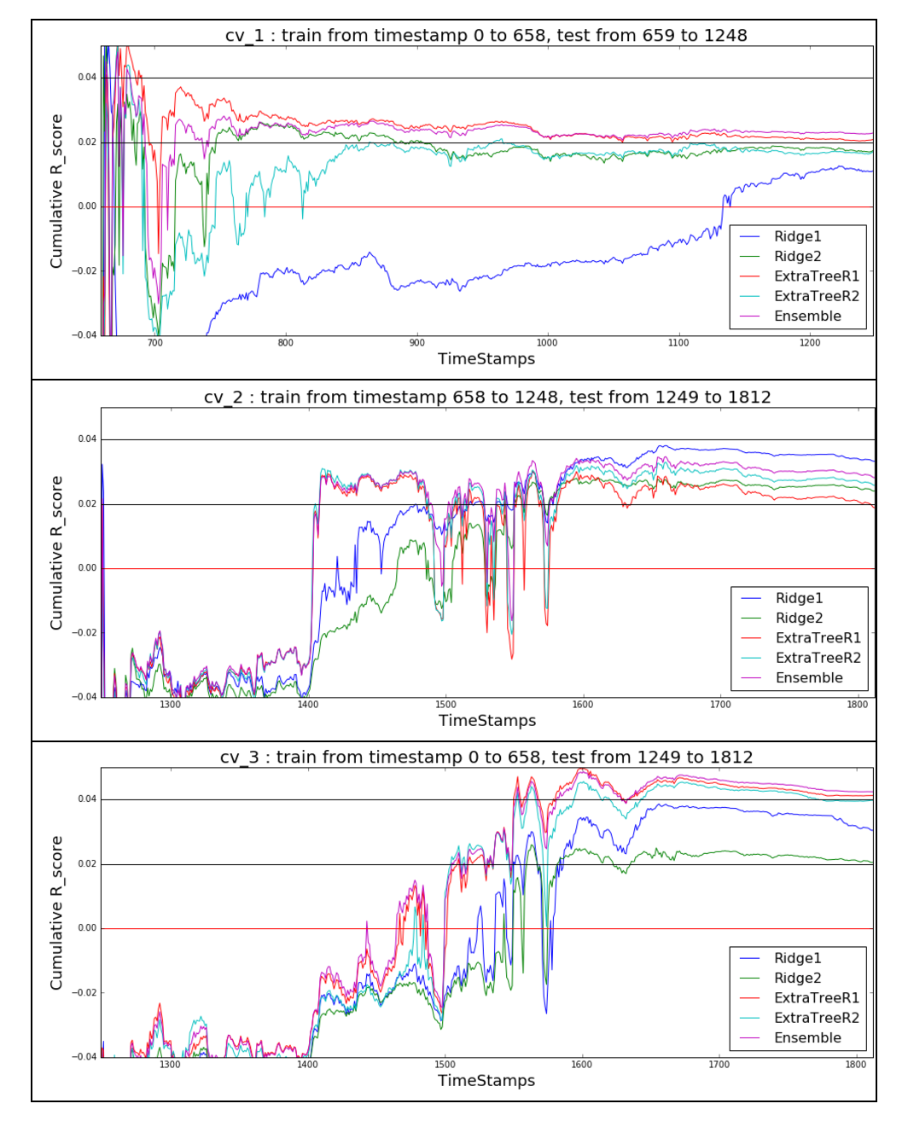

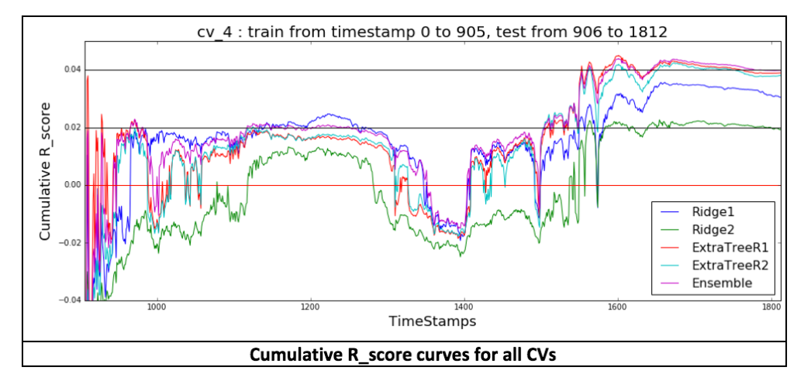

*Cumulative R_score curves for all CVs*

**What was your most important insight into the data and were you surprised by any of your findings?**

We had to pay attention to some of the engineered features (mostly features from the Feature_AMean category) as they were highly unreliable. A feature can show very good performance on a given CV and very bad results on other CVs. The study of fundamental_62 gave us some interesting insights about this feature. Its standard deviation by timestamp shows some interesting pattern. Surprisingly this pattern with the Volume pattern (at the same scale) have the same peaks at “slightly” regular intervals (nearly each 100 timestamps).

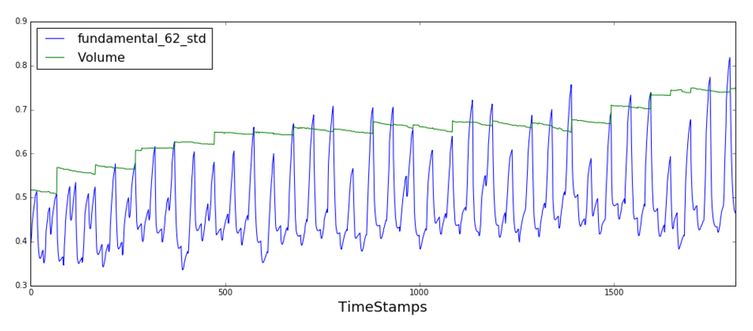

Also, technical_29 and technical_34 together boost the performance of Extra Tree models on CVs when they are used with technical_20, technical_30, technical_20_deMean, technical_30_deMean. In addition, Fundamental_62_AMean has a high correlation with the output and have a great impact on our CVs and the leaderboard for our Ridge models. The following figure shows the importance of features used in Extra Tree model:

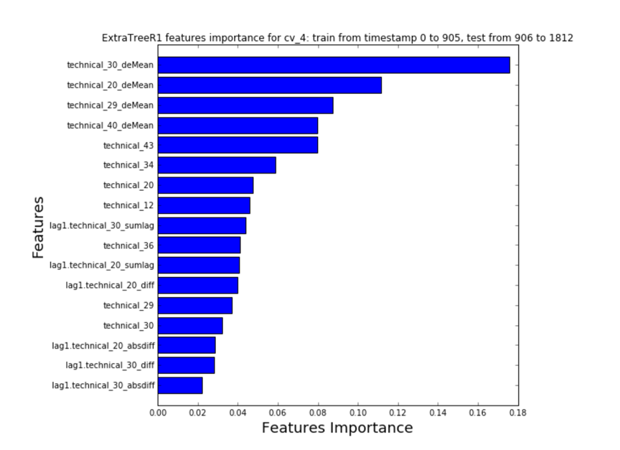

**Which tools did you use?**

For preprocessing and exploratory data analysis we used R and python but the code submission format was only in python. Also, we designed a hash based system in our python code that we can add engineered lag features easy and fast.

**How did you spend your time on this competition? (For example: What proportion on feature engineering vs. machine learning?**

We spent more than 80% on feature engineering, feature selection and understanding the data, and 20% on model ensembling, and tuning.

**What was the run time for both training and prediction of your winning solution?**

The winning solution took around 45 minutes to run and predict on Kaggle kernel.

**How well did you do on public/private leaderboard?**

The leaderboard shake up from public to private was quite impressive, as you can notice that many teams were overfit on the public leaderboard. There were teams which dropped more than 900 levels in private leaderboard. We were one of those few teams that did well both in public and private leaderboard.

### <http://blog.kaggle.com/2017/05/19/march-machine-learning-mania-1st-place-winners-interview-andrew-landgraf/>

### What was your approach? Did past March Mania competitions inform your winning strategy?

I kept my models simple and probabilistic. To model the outcomes of each game, I used a similar method as previous winners, [One Shining MGF](https://arxiv.org/abs/1412.0248). I created my own team efficiency ratings using a regression model so that I could calculate the historical ratings before the tournament started. The ratings, and a distance from home metric (more on this later), were used as covariates in a Bayesian logistic regression model (using the [rstanarm](https://cran.r-project.org/web/packages/rstanarm/index.html) package) to predict the outcomes of each game.

To model competitors’ submissions, I built a mixed effects model (with [lme4](https://cran.r-project.org/web/packages/lme4/index.html)) using data from the previous competitions. I used the logit of the submitted probability as the response, the team efficiencies as fixed effects, random intercepts for competitors and games, and random efficiency slopes for competitors. I guessed that there would be 500 competitors and that 400 of them would make 2 submissions, which wasn’t too far off.

The plot below shows the models for the two Final Four semi-final games. The black lines are densities of 100 simulations from the mixed effects model and the orange line is the true distribution of competitors’ predictions. They line up well for the SC vs. Gonzaga game and a little less so for the Oregon vs. UNC game. The posterior distribution from my model is much tighter than distributions from the competitors. My two submissions are the two vertical lines.

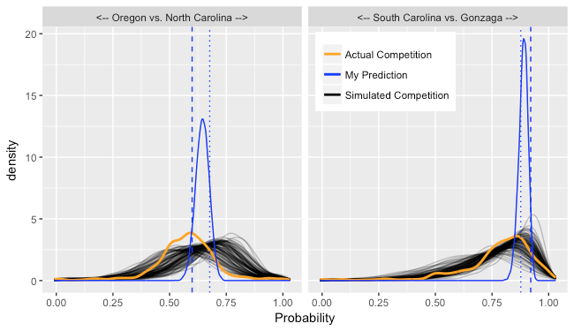

Finally, I used these models to come up with an optimal submission by simulating the bracket and the competitions’ submissions 10,000 times. This essentially gave me 10,000 simulated leaderboards of the competitors and my goal was to find the submission that most frequently showed up in the top 5 of the leaderboard. I tried to use a general-purpose optimizer, but it was very slow and it gave poor results. Instead, I sampled pairs of probabilities from the posterior many times, and chose the pair that was in the top 5 the most times. If I had naively used the posterior mean as a submission, my estimated probability of being in the top 5 would have been 15%, while my estimated probability of for the optimized submission (with two entries) went up to 25%.

The competitors’ submission model was trained on 2015 data. To assess the quality of the model, I have plotted the simulated distribution of the leaderboard losses for 2016 and 2017 and compared to the actual leaderboards. 2016 seems well in line, but 2017 had more submissions with lower losses than predicted. For both years, the actual 5th place loss was right in line with what was expected.

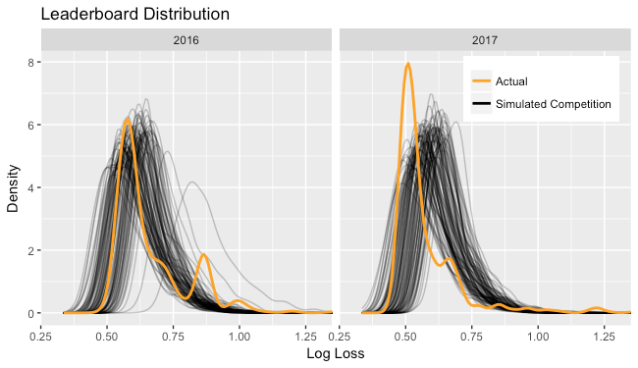

### Looking back, what would you do differently now?

A common strategy for this competition is to use the same predictions in both submissions except for the championship game, in which each team is given a 100% chance of winning in one of the submissions, guaranteeing that one of the two submissions will get the last game exactly correct. While I was aware of this strategy beforehand, I didn’t realize how good it is. If I had used this strategy, my estimated probability of being in the top 5 was 27%, 2 percentage points higher than my submission. This submission would have also won the competition.

### What have you taken away from this competition?

Sometimes it’s better to be lucky than good. The location data that I used had a [coding error](https://www.kaggle.com/c/march-machine-learning-mania-2017/discussion/28375#169431) in it. South Carolina’s Sweet Sixteen and Elite Eight games were coded as being in Greenville, SC instead of New York City. The led me to give them higher odds than most others, which helped me since they won. It is hard to say what the optimizer would have selected (and how it affected others’ models), but there is a good chance I would have finished in 2nd place or worse if the correct locations had been used.

<http://blog.kaggle.com/2017/04/10/exploring-the-structure-of-high-dimensional-data-with-hypertools-in-kaggle-kernels/>

**Dimensionality Reduction**

In comes dimensionality reduction, stage right. Dimensionality reduction is just what it sounds like– transforming a high-dimensional dataset into a lower-dimensional dataset. For example, [take this UCI ML dataset on Kaggle comprising observations about mushrooms](https://www.kaggle.com/uciml/mushroom-classification), organized as a big matrix. Each row is comprised of a bunch of features of the mushroom, like cap size, cap shape, cap color, odor etc. The simplest way to do dimensionality reduction might be to simply ignore some of the features (e.g. pick your favorite three—say size, shape, and color—and ignore everything else). However, this is problematic if the features you drop contained valuable diagnostic information (e.g. whether the mushrooms are poisonous).

A more sophisticated approach is to reduce the dimensionality of the dataset by only considering its principal components, or the combinations of features that explains the most variance in the dataset. Using a technique called principal components analysis (or PCA), we can reduced the dimensionality of a dataset, while preserving as much of its precious variance as possible. The key intuition is that we can create a *new* set of (a smaller number of) features, where each of the new features is some combination of the old features. For example, one of these new features might reflect a mix of shape and color, and another might reflect a mix of size and poisonousness. In general, each new feature will be constructed from a weighted mix of the original features.

Below is a figure to help with the intuition. Imagine that you had a 3 dimensional dataset (left), and you wanted to reduce it to a 2 dimensional dataset (right). PCA finds the *principal axes* in the original 3D space where the variance between points is the highest. Once we identify the two axes that explain the most variance (the black lines in the left panel), we can re-plot the data along just those axes, as shown on the right. Our 3D dataset is now 2D. Here we have chosen a low-dimensional example so we could visualize what is happening. However, this technique can be applied in the same way to higher-dimensional datasets.

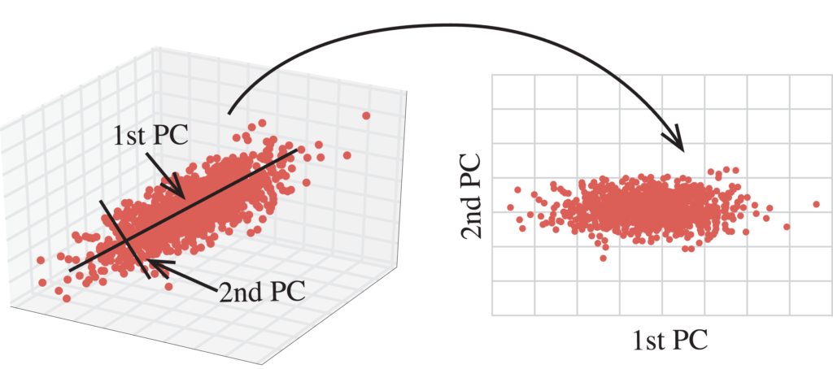

We created the [HyperTools package](http://hypertools.readthedocs.io/) to facilitate these sorts of dimensionality reduction-based visual explorations of high-dimensional data. The basic pipeline is to feed in a high-dimensional dataset (or a series of high-dimensional datasets) and, in a single function call, reduce the dimensionality of the dataset(s) and create a plot. The package is built atop many familiar friends, including matplotlib, scikit-learn and seaborn. HyperTools is designed with ease of use as a primary objective. We highlight two example use cases below.

**Mushroom foraging with HyperTools: Visualizing static ‘point clouds’**

First, let’s explore [the mushrooms dataset](https://www.kaggle.com/uciml/mushroom-classification) we referenced above. We start by importing the relevant libraries:

|  |  |
| --- | --- |
| 1  2 | import pandas as pd  import hypertools as hyp |

and then we read in our data into a pandas DataFrame:

|  |  |  |  |  |  |  |
| --- | --- | --- | --- | --- | --- | --- |
| 1  2 | data = pd.read_csv('../input/mushrooms.csv')  data.head() | | | | | |
| **index** | **class** | **cap-shape** | **cap-surface** | **cap-color** | **bruises** | **odor** | | **gill-attachment** |
| 0 | p | x | s | n | t | p | | f |
| 1 | e | x | s | y | t | a | | f |
| 2 | e | b | s | w | t | l | | f |
| 3 | p | x | y | w | t | p | | f |
| 4 | e | x | s | g | f | n | | f |
| 5 | e | x | y | y | t | a | | f |

Each row of the DataFrame corresponds to a mushroom observation, and each column reflects a descriptive feature of the mushroom (only some of the rows and columns are shown above). Now let’s plot the high-dimensional data in a low dimensional space by passing it to HyperTools. To handle text columns, HyperTools will first convert each text column into a series of binary ‘dummy’ variables before performing the dimensionality reduction. For example, if the ‘cap size’ column contained ‘big’ and ‘small’ labels, this single column would be turned into two binary columns: one for ‘big’ and one for ‘small’, where 1s represents the presence of that feature and 0s represents the absence (for more on this, see the [documentation](http://pandas.pydata.org/pandas-docs/stable/generated/pandas.get_dummies.html) for the get_dummies function in pandas).

|  |  |
| --- | --- |
| 1 | hyp.plot(data, 'o') |

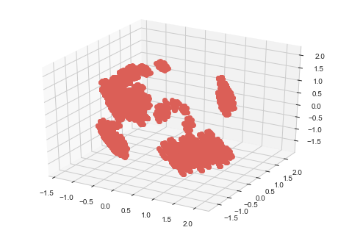

In plotting the DataFrame, we are effectively creating a three-dimensional “mushroom space,” where mushrooms that exhibit similar features appear as nearby dots, and mushrooms that exhibit different features appear as more distant dots. By visualizing the DataFrame in this way, it becomes immediately clear that there are multiple clusters in the data. In other words, all combinations of mushroom features are not equally likely, but rather certain combinations of features tend to go together. To better understand this space, we can color each point according to some feature in the data that we are interested in knowing more about. For example, let’s color the points according to whether the mushrooms are (p)oisonous or (e)dible (the class_labels feature):

|  |  |
| --- | --- |
| 1 | hyp.plot(data,'o', group=class_labels, legend=list(set(class_labels))) |

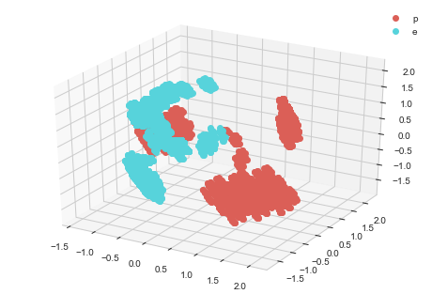

Visualizing the data in this way highlights that mushrooms’ poisonousness appears stable within each cluster (e.g. mushrooms that have similar features), but varies across clusters. In addition, it looks like there are a number of distinct clusters that are poisonous/edible. We can explore this further by using the ‘cluster’ feature of HyperTools, which colors the observations using k-means clustering. In the description of the dataset, it was noted that there were 23 different types of mushrooms represented in this dataset, so we’ll set the n_clusters parameter to 23:

|  |  |
| --- | --- |
| 1 | hyp.plot(data, 'o', n_clusters=23) |

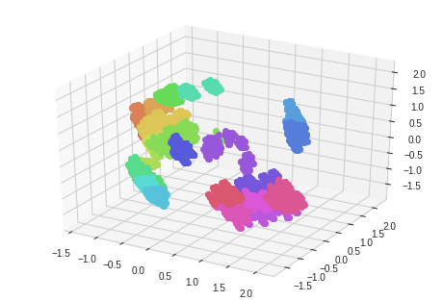

To gain access to the cluster labels, the clustering tool may be called directly using hyp.tools.cluster, and the resulting labels may then be passed to hyp.plot:

|  |  |
| --- | --- |
| 1  2 | cluster_labels = hyp.tools.cluster(data, n_clusters=23)  hyp.plot(data, group=cluster_labels) |

By default, HyperTools uses PCA to do dimensionality reduction, but with a few additional lines of code we can use other dimensionality reduction methods by directly calling the relevant functions from sklearn. For example, we can use t-SNE to reduce the dimensionality of the data using:

|  |  |
| --- | --- |
| 1  2  3  4 | from sklearn.manifold import TSNE  TSNE_model = TSNE(n_components=3)  reduced_data_TSNE = TSNE_model.fit_transform(hyp.tools.df2mat(data))  hyp.plot(reduced_data_TSNE,'o', group=class_labels, legend=list(set(class_labels))) |

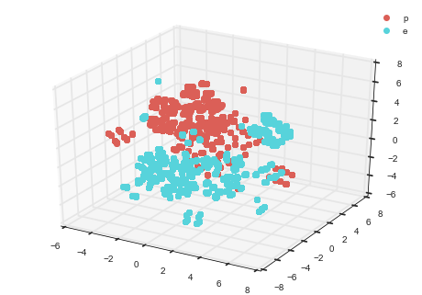

Different dimensionality reduction methods highlight or preserve different aspects of the data. A repository containing additional examples (including different dimensionality reduction methods) may be found [here](https://github.com/ContextLab/hypertools-paper-notebooks).

The data expedition above provides one example of how the geometric structure of data may be revealed through dimensionality reduction and visualization. The observations in the mushrooms dataset formed distinct clusters, which we identified using HyperTools. Explorations and visualizations like this could help guide analysis decisions (e.g. whether to use a particular type of classifier to discriminate poisonous vs. edible mushrooms). If you'd like to play around with HyperTools and the mushrooms dataset, [check out and fork this Kaggle Kernel](https://www.kaggle.com/andyh616/d/uciml/mushroom-classification/mushroom-foraging-with-hypertools)!



**Climate science with HyperTools: Visualizing dynamic data**

Whereas the mushrooms dataset comprises static observations, here we will take a look at some global temperature data, which will showcase how HyperTools may be used to visualize timeseries data using dynamic *trajectories*.

This next dataset is made up of monthly temperature recordings from a sample of 20 global cities over the 138 year interval ranging from 1875–2013. To prepare this dataset for analysis with HyperTools, we created a time by cities matrix, where each row is a temperature recording for subsequent months, and each column is the temperature value for a different city. You can replicate this demo by using the [Berkeley Earth Climate Change dataset on Kaggle](https://www.kaggle.com/berkeleyearth/climate-change-earth-surface-temperature-data) or by cloning [this GitHub repo](https://github.com/ContextLab/hypertools-paper-notebooks). To visualize temperature changes over time, we will use HyperTools to reduce the dimensionality of the data, and then plot the temperature changes over time as a line:

|  |  |
| --- | --- |
| 1 | hyp.plot(temps) |

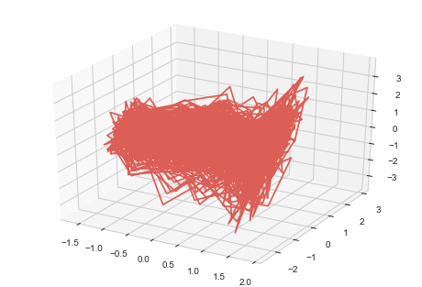

Well that just looks like a hot mess, now doesn’t it? However, we promise there is structure in there– so let’s find it! Because each city is in a different location, the mean and variance of its temperature timeseries may be higher or lower than the other cities. This will in turn affect how much that city is weighted when dimensionality reduction is performed. To normalize the contribution of each city to the plot, we can set the normalize flag (default value: False). Setting normalize='across' HyperTools incorporates a number of useful normalization options, which you can read more about [here](http://hypertools.readthedocs.io/en/latest/auto_examples/plot_normalize.html#sphx-glr-auto-examples-plot-normalize-py).

|  |  |
| --- | --- |
| 1 | hyp.plot(temps, normalize='across') |



Now we're getting somewhere! Rotating the plot with the mouse reveals an interesting shape to this dataset. To help highlight the structure and understand how it changes over time, we can color the lines by year, where more red lines indicates early and more blue lines indicate later timepoints:

|  |  |
| --- | --- |
| 1 | hyp.plot(temps, normalize='across', group=years.flatten(), palette='RdBu_r') |

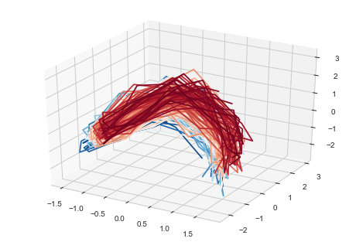

Coloring the lines has now revealed two key structural aspects of the data. First, there is a systematic shift from blue to red, indicating a systematic change in the pattern of global temperatures over the years reflected in the dataset. Second, within each year (color), there is a cyclical pattern, reflecting seasonal changes in the temperature patterns. We can also visualize these two phenomena using a two dimensional plot:

|  |  |
| --- | --- |
| 1 | hyp.plot(temps, normalize='across', group=years.flatten(), palette='RdBu_r', ndims=2) |

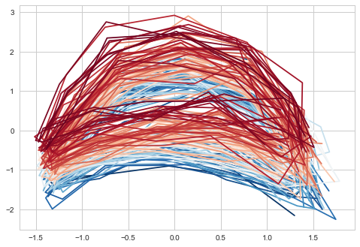

Now, for the grand finale. In addition to creating static plots, HyperTools can also create animated plots, which can sometimes reveal additional patterns in the data. To create an animated plot, simply pass animate=True to hyp.plot when visualizing timeseries data. If you also pass chemtrails=True, a low-opacity trace of the data will remain in the plot:

|  |  |
| --- | --- |
| 1 | hyp.plot(temps, normalize='across', animate=True, chemtrails=True) |



That pleasant feeling you get from looking at the animation is called “global warming.”

This concludes our exploration of climate and mushroom data with HyperTools. For more, please visit the project's [GitHub repository](https://github.com/ContextLab/hypertools), [readthedocs site](http://hypertools.readthedocs.io/en/latest/index.html), a [paper](https://arxiv.org/abs/1701.08290) we wrote, or our demo [notebooks](https://github.com/ContextLab/hypertools-paper-notebooks).

<http://blog.kaggle.com/2017/03/29/predicting-house-prices-playground-competition-winning-kernels/>

**What motivated you to create it?**

I had just learned about [XGBoost](https://cran.r-project.org/web/packages/xgboost/xgboost.pdf), and was interested in doing a start to finish project comparing xgb to regression and random forest side by side. I though others might also want to be able to see how the procedures compared to each other. I learn a lot by doing, I am a hands-on learner as code is concerned, so this was a great opportunity for me.

[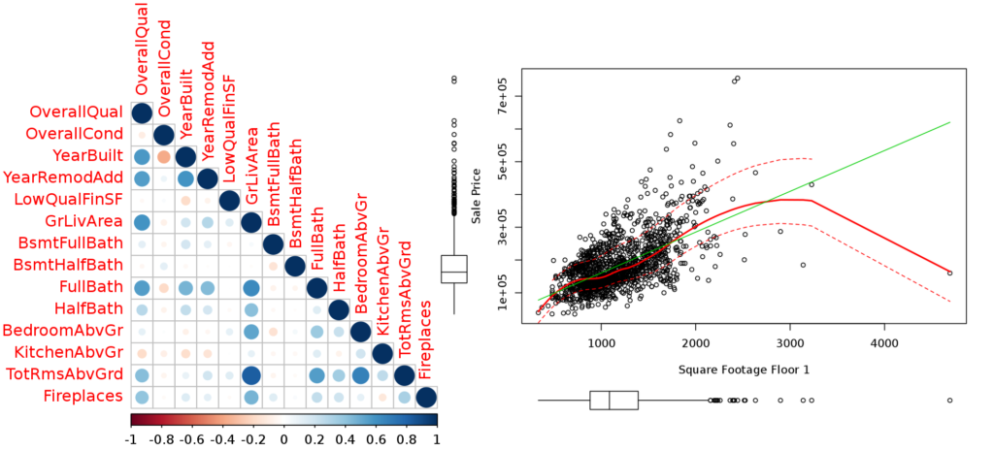](https://www.kaggle.com/skirmer/house-prices-advanced-regression-techniques/fun-with-real-estate-data)

Stephanie's kernel [Fun with Real Estate Data](https://www.kaggle.com/skirmer/house-prices-advanced-regression-techniques/fun-with-real-estate-data) includes everything you need from data exploration and cleaning to model building including XGBoost.

**What did you learn from your analysis?**

Oh goodness, I learned a lot. I have since learned even more, and my xgb implementations today are better, I think, but in this I learned about setting up the script so it would be smooth and make sense to the reader, so it would run at a reasonable speed (not that easy, random forests are slow), and I really put some work into the feature engineering and just simply learned a lot about how houses are classified/measured.

**Can you tell us about your approach in the competition?**

Entering the competition with my results was kind of an afterthought. I started work early on in this competition because it was a dataset that I could actually work with on the kernel structure or on my local machine (most competition datasets on Kaggle are way too big for my hardware/software to manage). I wanted to write the kernel first, and then it was just easy to enter from that interface so I did. I’m pretty proud of the results given it was my first reasonably competent implementation of XGBoost!

[**Comprehensive Data Exploration with Python**](https://www.kaggle.com/pmarcelino/house-prices-advanced-regression-techniques/comprehensive-data-exploration-with-python)

**Created by**: [Pedro Marcelino](https://www.kaggle.com/pmarcelino)   
**Language**: Python

**What motivated you to create it?**

My main motivation was learning. Currently, I am looking to develop my skills as a data scientist and I found out that Kaggle is the best place to do it. According to my experience, any learning process gets easier if you can relate your study subject with something that you already know. In Kaggle you can do that because you can always find a dataset to fall in love with. That is what happened in my case. Having a background in Civil Engineering, the ‘House Prices: Advanced Regression Techniques’ competition was an obvious choice, since predicting house prices was a problem I had already thought about. In that sense, Kaggle works great for me and it is the place to go when I want to learn data science topics.

**What did you learn from your analysis?**

The most important lesson that I took from my analysis was that documenting your work is a great advantage. There are many reasons why I believe in this. First, writing helps clarify thinking and that is essential in any problem solving task. Second, when everything is well documented, it is easier to use your work for future reference in related projects. Third, if you document your work, you will improve the quality of the feedback you will receive and, consequently, you get more chances to improve your work. In the beginning, it might feel frustratingly slow to document everything, but you will get faster with practice. In the end, you will realize that it can be a funny exercise (and feel compelled to even add some jokes to your text).

[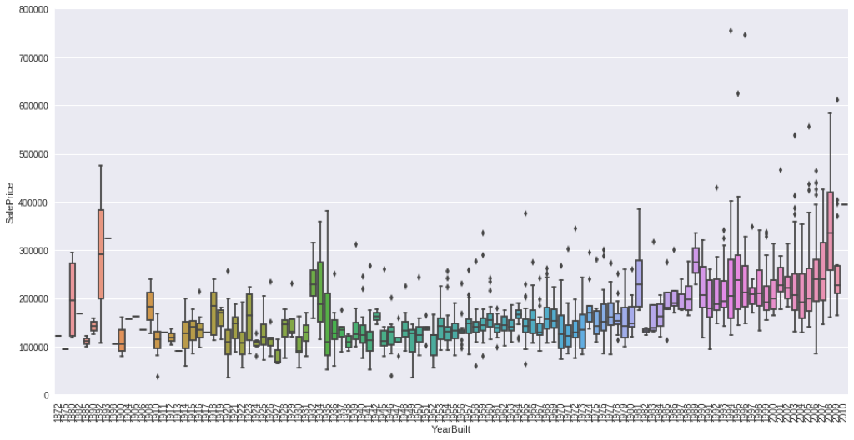](https://www.kaggle.com/pmarcelino/house-prices-advanced-regression-techniques/comprehensive-data-exploration-with-python)

The distribution of house prices by year built in Pedro's kernel [Comprehensive Data Exploration in Python](https://www.kaggle.com/pmarcelino/house-prices-advanced-regression-techniques/comprehensive-data-exploration-with-python).

**Can you tell us about your approach in the competition?**

My approach was to focus on a specific aspect of the data science process and look for a solid bibliographic reference that could guide my work. For this competition, I opted to improve my skills in the aspect of data exploration. As a bibliographic reference, I used the book ‘Multivariate Data Analysis’ (Hair et al., 2014), in particular its Chapter 3 ‘Examining your data’. Since the book is well organized and written in a straightforward way, it is easy to follow it and use it as bridge between theory and practice. This is the approach that I usually follow when I am learning the basics: define the problem that I want to solve, look for related references and adapt them to my needs. Nothing more than ‘standing on the shoulders of giants’.



**Pre-Processing and Feature Engineering**

[**A Study on Regression Applied to the Ames Dataset**](https://www.kaggle.com/juliencs/house-prices-advanced-regression-techniques/a-study-on-regression-applied-to-the-ames-dataset)

**Created by**: [Julien Cohen Solal](https://www.kaggle.com/juliencs)   
**Language**: Python

**What motivated you to create it?**

Playground competitions are all about learning and sharing. I’m no expert at all, and was even less so when I published this kernel, but most of what I learned about machine learning models, I learned on Kaggle. If I recall correctly, I published it pretty early in the competition. There were already a few really interesting kernels, but I felt some of the work I had done hadn’t been presented anywhere else thus far, so there was my opportunity to share.

Around this period, I also just finished reading a book which I really liked (Python Machine Learning by Sebastian Raschka), and I couldn’t wait to apply some of the things I had read about on a dataset which looked interesting to me. When my first few submissions scored pretty decent results (at that moment at least), I figured my code was probably good enough that a few people could probably learn a thing or two reading it, and I could also maybe get some feedback to improve it.

[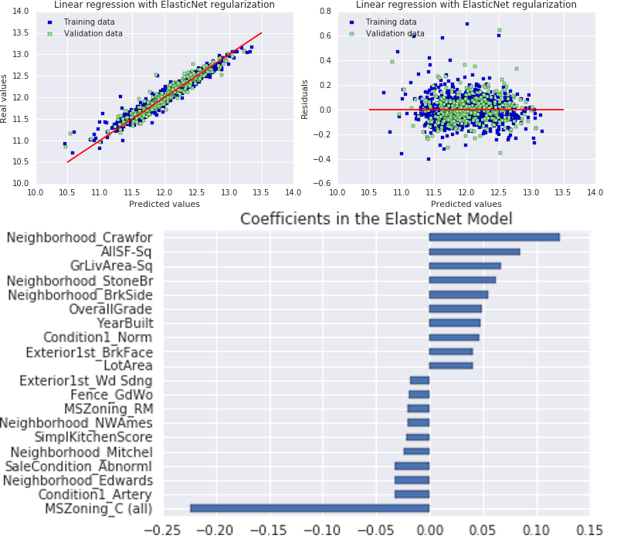](https://www.kaggle.com/juliencs/house-prices-advanced-regression-techniques/a-study-on-regression-applied-to-the-ames-dataset)

Julien's kernel [A Study on Regression Applied to the Ames Dataset](https://www.kaggle.com/juliencs/house-prices-advanced-regression-techniques/a-study-on-regression-applied-to-the-ames-dataset) uses every trick in the book to unleash the potential power of linear regression.

**What did you learn from your analysis?**

Well, strictly speaking about the topic of house prices, it confirmed what was pretty much universally known: it’s all about location and size. Other features like overall quality matter as well, but much, much less.

Now about applying machine learning to real-world problems, this was a real learning experience for me. First of all, feature engineering is fun! It’s definitely my favorite part of the overall process, the creativity aspect of it, especially on a dataset like this one where features aren’t anonymized and you can really focus on trying to improve your dataset with new features that make sense, not just blindly combine features and try random transformations on those.

Also, applying regularization when using Linear Regression is pretty much essential. It penalizes extreme parameter weights and as such allows us to find a much better bias/variance tradeoff and to avoid overfitting.

**Can you tell us about your approach in the competition?**

Right from the start, I knew I wouldn’t try to aim for the top spots (I wouldn’t be able to anyway!). I’m not really interested in stacking tens or hundreds of finely-tuned models, which seems to be pretty much necessary to win any Kaggle competition these days. I was in it to test some techniques I had heard about, and learn some new ones via the forum or the kernels.

I tried to mix the most interesting ideas I could read about in the kernels that were already published, mix those with my own, and go from there. I was using cross-validation to validate every single preprocessing concept, but it was at times a frustrating process, as the dataset is really small, and it was hard to distinguish the signal from the noise. Some features that made so much sense to me were actually downgrading my score. All in all it was still a great learning experience, and I’m happy I have been able to share some knowledge as well.



**Insightful Visualizations**

[**A Clear Example of Overfit**](https://www.kaggle.com/ozagordi/house-prices-advanced-regression-techniques/a-clear-example-of-overfitting)

**Created by**: [Osvaldo Zagordi](https://www.kaggle.com/ozagordi)   
**Language**: R

**What motivated you to create it?**

What I liked about this competition was its small dataset, which allowed me to experiment quickly on my old laptop, and the fact that everybody can easily have a feeling of what a house price is. Your RMSE is zero-point-something, but how does it translate on the prediction? Am I off the price by one thousand, ten thousand, or one hundred thousand? Plotting the predicted vs. the actual prices was then a natural thing to do.

**What did you learn from your analysis?**

Trivially, I learned that overfitting can hit me much more then I would have expected. The prediction of gradient boosted trees on the training set is extremely good, almost perfect! Of course, I was in a situation of slightly more than 50 predictors and 700 observations. Still, it was remarkable to observe the trees adapt so perfectly to the observations.

[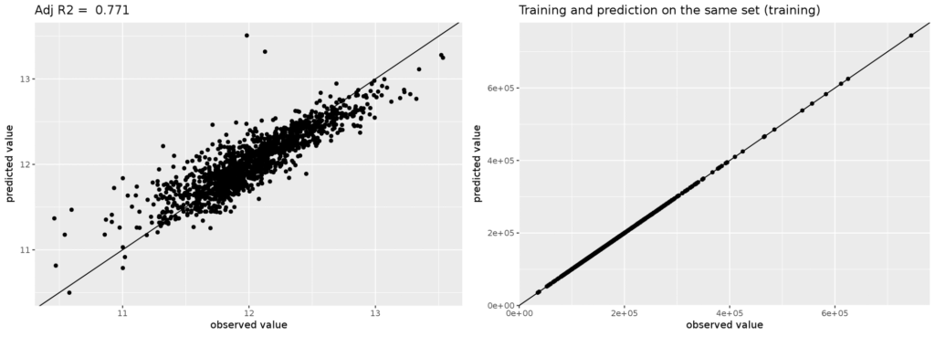](https://www.kaggle.com/ozagordi/house-prices-advanced-regression-techniques/a-clear-example-of-overfitting)

Osvaldo delivers in his kernel [A Clear Example of Overfitting](https://www.kaggle.com/ozagordi/house-prices-advanced-regression-techniques/a-clear-example-of-overfitting).

**Can you tell us about your approach in the competition?**

Competing at high level in Kaggle quickly becomes hard. I was experimenting exactly with a method aimed at avoiding overfitting when I made that observation. In the end I did not write a kernel on this technique (maybe next time), and I did not even invest much energy in trying to climb the leaderboard. But I decided it was worth writing a kernel showing the example of the overfit. I thought it was somehow “educational”. In general, communicating the results is my favourite part of the whole analysis, even more so for this playground competition.

<http://blog.kaggle.com/2017/03/24/leaf-classification-competition-1st-place-winners-interview-ivan-sosnovik/>

## Let’s get technical

When I joined the competition, several kernels with top 20% scores were published. The solutions used the initially extracted features and Logistic Regression. It gave . And no significant improvement could be achieved by tuning of the parameters. In order to enhance the quality, feature engineering had to be performed. Seemed like no one had done it because the top solution had slightly better score than mine.

### Feature engineering

I did first things first and plotted the images for each of the classes.

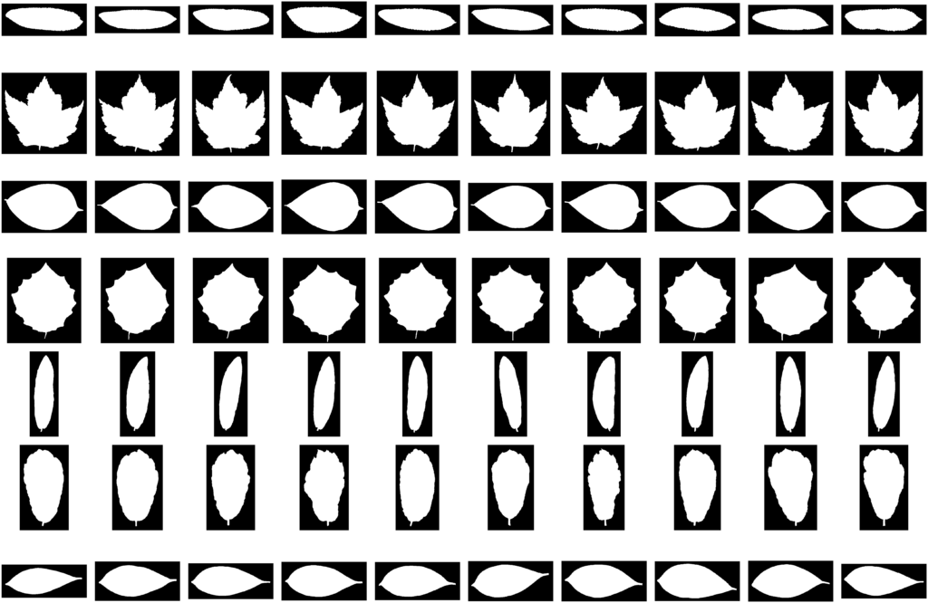

10 images from the train set for each of 7 randomly chosen classes.

The raw images had different resolution, rotation, aspect ratio, width, and height. However, the variation of each of the parameters within the class is less than between the classes. Therefore, some informative features could be constructed just on the fly. They are:

* width and height
* aspect ration: width / height
* square: width * height
* is orientation horizontal: int(width > height)

Another very useful feature that seemed to help is the average value of the pixels of the image.

I added these features to the already extracted ones. Logistic regression enhanced the result. However, most of the work was yet to be done.

All of the above-described features represent nothing about the content of the image.

##### PCA

Despite the success of neural networks as feature extractors, I still like PCA. It is simple and allows one to get the useful representation of the image in . First of all, the images were rescaled to the size of . Then PCA was applied. The components were added to the set of previously extracted features.

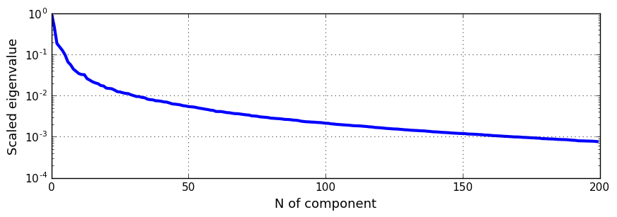

Eigenvalues of the covariance matrix.

The number of components was varied. Finally, I used principle components. This approach showed .

##### Moments and hull

In order to generate even more features, I used OpenCV. There is a great [tutorial](http://docs.opencv.org/3.1.0/dd/d49/tutorial_py_contour_features.html) on how to get the moments and hull of the image. I also added some pairwise multiplication of several features.

The final set of features is the following:

* Initial features
* height, width, ratio etc.
* PCA
* Moments

The Logistic Regression demonstrated .

## The main idea

All of the above-described demonstrated good result. Such result would be appropriate for real life application. However, it could be enhanced.

### Uncertainty

The majority of objects had certain decision: there was the only class with and the rest had . However, I found several objects with uncertainty in a prediction like this:

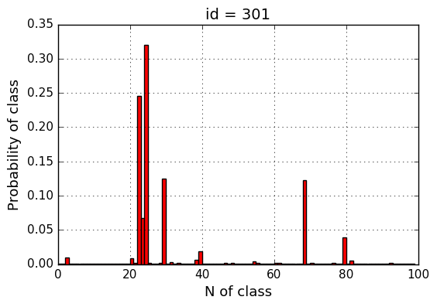

Prediction of logistic regression.

The set of confusion classes was small (15 classes divided into several subgroups), so I decided to look at the pictures of the leaves and check if I can classify them. Here is the result:

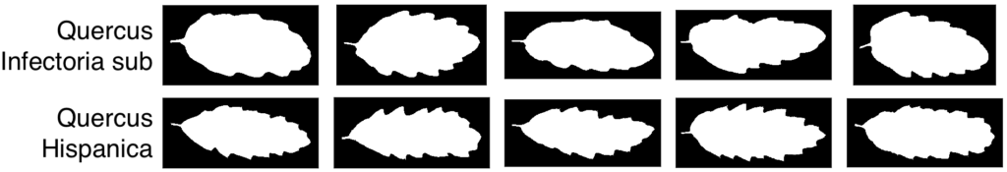

Quercus confusion group.

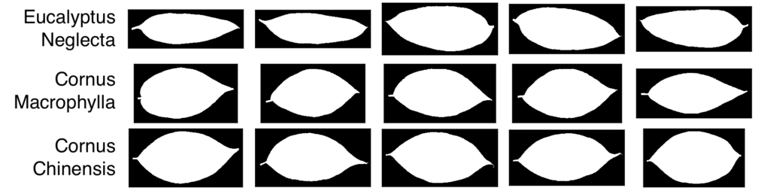

Eucalyptus and Cornus confusion group.

I must admit that Quercus’ (Oak) leaves look almost the same for different subspecies. I assume, that I could distinguish Eucalyptus from Cornus, but the classification of subspecies seems complicated to me.

### Can you really see the random forest for the leaves?

The key idea of my solution was to create another classifier, which will make predictions only for confusion classes. The first one I tried was RandomForestClassifier from sklearn and it gave excellent result after the tuning of hyperparameters. The random forest was trained on the same data as logistic regression, but only the objects from confusion classes were used.

If logistic regression gave uncertain predictions for an object then the prediction of the random forest classifier was used. Random forest gave the probabilities for 15 classes, the rest assumed to be absolute .

The final pipeline is the following:

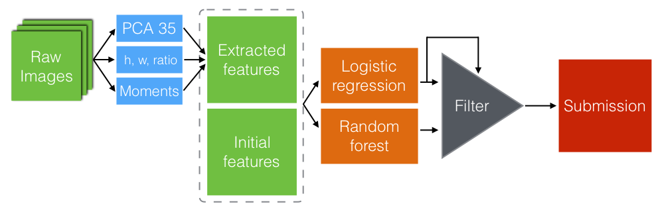

Final pipeline.

### Threshold

The leaderboard score was calculated on the whole dataset. That is why some risky approaches could be used in this competition.

Submissions are evaluated using the multi-class logloss.   
  
where - number of objects and classes respectively, is the prediction and is the indicator: if object is in class , otherwise it equals to . If the model correctly chose the class, then the following approach will decrease the overall logloss, otherwise, it will increase dramatically.

After thresholding, I got the score of . That’s it. All the labels are correct.

## What else?

I’ve tried several methods that showed appropriate result but was not used in the final pipeline. Moreover, I had some ideas on how to make the solution more elegant. In this section, I’ll try to discuss them.

#### XGBoost

[XGBoost](https://github.com/dmlc/xgboost) by **dmlc** is a great tool. I’ve used it in several competitions before and decided to train it on the initially extracted features. It demonstrated the same score as logistic regression or even worse, but the time consumption was a way bigger.

#### Submission blending

Before I came up with an idea of Random Forest as the second classifier, I tried different one-model methods. Therefore I collected lots of submissions. The trivial idea is to blend the submissions: to use the mean of the predictions or weighted mean. The result did not impress me either.

#### Neural networks

Neural networks were one of the first ideas I tried to implement. Convolutional Neural Networks are good feature extractors, therefore, they could be used as a first-level model or even as a main classifier. The original images came with different resolution. I rescaled them to . The training of CNN on my laptop was too time-consuming to choose the right architecture in reasonable time, so I declined this idea after several hours of training. I believe, that CNNs could give accurate predictions for this dataset.

<http://blog.kaggle.com/2017/02/27/allstate-claims-severity-competition-2nd-place-winners-interview-alexey-noskov/>

**Data preprocessing and feature engineering**

First, I needed to fix skew in target variable. Initially I applied log-transform, and it worked good enough, but some time after I switched to other transformations like log(loss + 200) or loss ^ 0.25, which worked somewhat better.

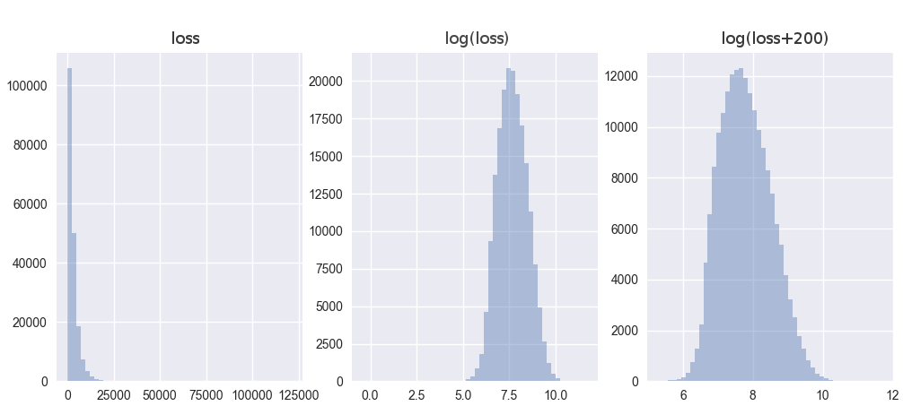

Target variable and its transformations.

For features - first of all, I needed to encode categorical variables. For this I used basic one-hot encoding for some models, but also so-called lexical encoding, when value of encoded category is produced from its name (A becomes 0, B - 1, Z - 26, AA - 27, and so on).

I tried to find some meaningful features, but had no success at it. Also there were [some kernels](https://www.kaggle.com/c/allstate-claims-severity) which provided insights into the nature of some variables, and tried to de-mangle them but I couldn’t get any improvement from it. So, I switched to using general automated methods.

The first of such methods was, of course, SVD, which I’ve applied to numerical variables and one-hot encoded categorical features. It helped to improve some high-variance models, like FM and NN.

Second, and more complex, was clustering the data and creating a new set of features based on the distance to cluster centers (i.e., applying [RBF](http://ccy.dd.ncu.edu.tw/%7Echen/course/Neural/ch5/RBF.htm) to them) - it helped to create a bunch of unsupervised non-linear features, which helped to improve most of my models.

And third, the last trick I used was forming categorical interaction features, applying lexical encoding to them. These combinations may be easily extracted from XGBoost models by just trying the most important categorical features, or better, analysing the model dump with the excellent [Xgbfi](https://github.com/Far0n/xgbfi) tool.

**First-level models**

Based on these features, I built a lot of different models which I evaluated using the usual k-fold cross-validation.

First of all, there was linear regression, which gave me about 1237.43406 CV / 1223.28163 LB score, which is not very much of course, but provides some baseline. But after adding cluster features to it, it became 1202.70592 CV / 1189.64998 LB, which is much better for such a simple model.

Then, I tried scikit-learn [RandomForestRegressor](http://scikit-learn.org/stable/modules/generated/sklearn.ensemble.RandomForestRegressor.html) and [ExtraTreesRegressor](http://scikit-learn.org/stable/modules/generated/sklearn.ensemble.ExtraTreesRegressor.html) models, of which random forest was best, giving 1199.82233 CV / 1176.44433 LB after some tuning, and improved to 1186.23675 CV / 1166.85340 LB after adding categorical feature combinations. One problem with this model was that however scikit-learn supports MAE loss, it’s very slow and impossible to use, so I needed to use basic MSE, which has some bias in this competition.

The best model of scikit-learn which helped me was [GradientBoostingRegressor](http://scikit-learn.org/stable/modules/generated/sklearn.ensemble.GradientBoostingRegressor.html), which was able to directly optimize MAE loss and gave me 1151.11060 CV / 1126.30971 LB

I also tried [LibFM](https://github.com/srendle/libfm/) model, which gave me 1196.11333 CV / 1155.68632 LB in a basic version and 1177.69251 CV / 1150.37290 LB after adding cluster features to it.

But the main workhorses of this competitions were, of course, [XGBoost](http://xgboost.readthedocs.io/en/latest/) and neural net models:

In the beginning, my XGBoost models provided something about 1133.00048 CV / 1112.86570 LB, but then I’ve applied some tricks which improved it to 1122.64977 CV / 1105.43686 LB:

* Averaging multiple runs of XGBoost with different seeds - it helps to reduce model variance;
* Adding categorical combination features;
* Modifying objective function to be closer to MAE;
* Tuning model parameters - I didn’t have much experience with it before, so [this thread in Kaggle forums](https://www.kaggle.com/c/santander-customer-satisfaction/forums/t/20662/) helped me a lot.

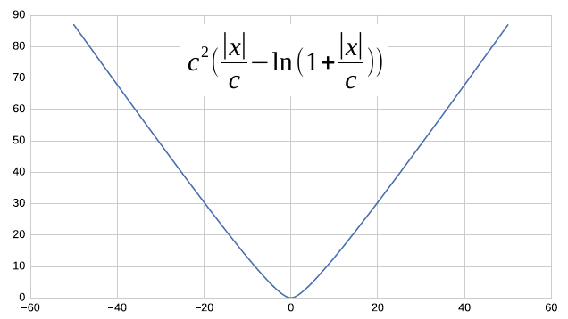

Custom objective function for XGBoost.

The other model that provided great results was neural net, implemented using the [Keras](https://keras.io/) library. I used basic multi-layer perceptron with 3 hidden layers which gave me somewhat about 1134.92794 CV / 1116.44915 LB in initial versions and improved to 1130.29286 CV / 1110.69527 LB after tuning and applying some tricks:

* Averaging multiple runs, again;
* Applying exponential moving average to weights of single network, using [this implementation](https://gist.github.com/soheilb/c5bf0ba7197caa095acfcb69744df756);
* Adding SVD and cluster features;
* Adding batch normalization and dropout;

**Model tuning**

In this competition, model hyperparameter tuning was very important, so I’ve contributed a lot of time in it. There are three main approaches here:

* Manual tuning, which works good when you have some intuition about parameter behaviour and may estimate model performance before its training completes by per-epoch validation scores;
* Uninformed parameter search - using [GridSearchCV](http://scikit-learn.org/stable/modules/generated/sklearn.model_selection.GridSearchCV.html) or [RandomizedSearch](http://scikit-learn.org/0.17/modules/generated/sklearn.grid_search.RandomizedSearchCV.html) from sklearn package, or similar - most simple of all;
* Informed search using [HyperOpt](http://hyperopt.github.io/hyperopt/) or [BayesOptimization](https://github.com/fmfn/BayesianOptimization/) or similar package - it tries to fit some model to scores of different parameter sets and selects the most promising point for each next try - so it usually finds the optimum a lot faster than uninformed search.

I used manual tuning for XGBoost and NN models which provide per-epoch validation scores and bayes optimization package for the others.

**Second level**

After getting a lot of models, I combined them in the second level, training new models on out-of-fold predictions:

* Linear regression, which gave me 1118.45564 CV / 1113.08059 LB score
* XGBoost - 1118.16984 CV / 1100.50998 LB
* Neural net - 1116.40752 CV / 1098.91721 LB (it was enough to get top-16 in public, and top-8 in private)
* Gradient boosting - 1117.41247 CV / 1099.60251 LB

I haven’t had much experience with stacking before and so I was really impressed by these results, but wanted to get even more.

So, the first thing I did was correct the bias of some stacked models - linear regression and XGBoost optimized some objective which was not equal to the objective of the competition, which resulted in overestimating low values and underestimating high ones. This bias is really small, but the competition was very close, so every digit counted.

This bias can be seen on the next figure where logs of XGBoost predictions are plotted against target logs with and a median regression line. If it was unbiased, the median regression should be the same as diagonal, but it's not (offset is most visible where red arrows are).

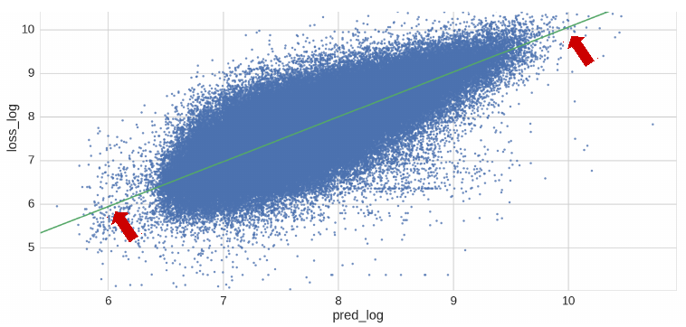

XGBoost bias.

I took XGBoost predictions to some small power p (around 1.03), normalized to preserve its median, and it improved my score to 1117.35084 CV / 1099.63060 LB.

Not bad, but maybe I can get even more by combining predictions of these models?

**Third level**

So, I built a third level. As each new stacking level becomes more and more unstable, I needed something really simple here, which may optimize the competition’s metric directly. So, I chose to use median regression from the [statsmodels](http://statsmodels.sourceforge.net/devel/index.html) package.

The main problem of this approach was lack of regularization, so it wasn’t very stable and had a lot of noise. To fight it I applied some tricks:

* Training model on many subsamples and averaging predictions;
* Reducing input dimensionality - grouping similar models of previous layers and using group averages as features;
* Averaging best 10 submissions for a final one.

It allowed me to get 1098.07061 in public LB, and 1110.01364 in private, which corresponds to second place.

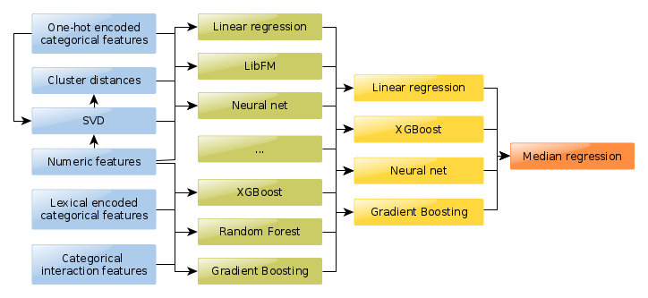

Final pipeline.

**Lessons learned**

So, this competitions helped me a lot, mainly in two main areas in which I lacked experience in before - model hyperparameter tuning (especially for XGBoost, where I got good hyperparameter intuition) and stacking, which I underestimated before.

Also, I tried a lot of different models and got intuition about how they work with different target, feature transformations, and so on.

# Exploratory Analysis Zillow

### Welcome and good luck to you all at Zillow’s Home Value prediction!

#### with a price pool of 1.2 Million Dollar

Here is a first exploratory analysis of the competition dataset. We are provided with a list of real estate properties in three counties (Los Angeles, Orange and Ventura, California) data in 2016.

Zillow provides a “Zestimate”, which is an estimated property value.

Our task in this competition is to predict the the difference between the actual price and the estimate of the price (Zestimate). So, in fact we are predicting, where Zillow’s Zestimate will be good, and where it will be bad.

So, far so good. However, we don’t have to predict a single value, but instead for 6 different time points (from October 2016 to December 2017) (see sample submission)

The dataset consists of information about 2.9 million properties and is grouped into 2 files:

* properties_2016.csv (containing information about the properties themselves)
* train_2016.csv (containing information about the transcations)

Let’s look at the dataset:

### Read in the data

library(data.table)

library(dplyr)

library(ggplot2)

library(stringr)

library(DT)

library(tidyr)

library(corrplot)

library(leaflet)

library(lubridate)

properties <- fread('../input/properties_2016.csv')

transactions <- fread('../input/train_2016.csv')

sample_submission <- fread('../input/sample_submission.csv')

Lets first have a look at these files:

### Peek at the dataset

* [Properties](https://www.kaggle.io/svf/1197101/205cfffc70ec42601188bd14d6dc512d/__results__.html#properties)
* [Transactions](https://www.kaggle.io/svf/1197101/205cfffc70ec42601188bd14d6dc512d/__results__.html#transactions)
* [Sample Submission](https://www.kaggle.io/svf/1197101/205cfffc70ec42601188bd14d6dc512d/__results__.html#sample-submission)

There is a total of 58 features per property. You can scroll the x-axis to see all features.

|  | **parcelid** | | **airconditioningtypeid** | | | | | | **architecturalstyletypeid** | | | | | | | | **basementsqft** | | | | **bathroomcnt** | | | | | **bedroomcnt** | | | | | | **buildingclasstypeid** | | **buildingqualitytypeid** | | | **calculatedbathnbr** | | | | | | | **decktypeid** | | **finishedfloor1squarefeet** | | **calculatedfinishedsquarefeet** | | | | **finishedsquarefeet12** | | | **finishedsquarefeet13** | | | | | | | | **finishedsquarefeet15** | | | | | **finishedsquarefeet50** | | | **finishedsquarefeet6** | | **fips** | | **fireplacecnt** | | | | **fullbathcnt** | **garagecarcnt** | **garagetotalsqft** | **hashottuborspa** | **heatingorsystemtypeid** | **latitude** | **longitude** | **lotsizesquarefeet** | **poolcnt** | **poolsizesum** | **pooltypeid10** | **pooltypeid2** | **pooltypeid7** | **propertycountylandusecode** | **propertylandusetypeid** | **propertyzoningdesc** | **rawcensustractandblock** | **regionidcity** | **regionidcounty** | **regionidneighborhood** | **regionidzip** | **roomcnt** | **storytypeid** | **threequarterbathnbr** | **typeconstructiontypeid** | **unitcnt** | **yardbuildingsqft17** | **yardbuildingsqft26** | **yearbuilt** | **numberofstories** | **fireplaceflag** | **structuretaxvaluedollarcnt** | **taxvaluedollarcnt** | **assessmentyear** | **landtaxvaluedollarcnt** | **taxamount** | **taxdelinquencyflag** | **taxdelinquencyyear** | **censustractandblock** |
| --- | --- | --- | --- | --- | --- | --- | --- | --- | --- | --- | --- | --- | --- | --- | --- | --- | --- | --- | --- | --- | --- | --- | --- | --- | --- | --- | --- | --- | --- | --- | --- | --- | --- | --- | --- | --- | --- | --- | --- | --- | --- | --- | --- | --- | --- | --- | --- | --- | --- | --- | --- | --- | --- | --- | --- | --- | --- | --- | --- | --- | --- | --- | --- | --- | --- | --- | --- | --- | --- | --- | --- | --- | --- | --- | --- | --- | --- | --- | --- | --- | --- | --- | --- | --- | --- | --- | --- | --- | --- | --- | --- | --- | --- | --- | --- | --- | --- | --- | --- | --- | --- | --- | --- | --- | --- | --- | --- | --- | --- | --- | --- | --- | --- | --- | --- | --- | --- |
|  | |  | |  |  |  |  |  | |  |  |  |  |  |  |  | |  |  |  | |  |  |  |  | |  |  |  |  |  | |  | |  |  | |  |  |  |  |  |  | |  | |  | |  |  |  | |  |  | |  |  |  |  |  |  |  | |  |  |  |  | |  |  | |  | |  | |  |  |
| 1 | | 10754147 | |  |  |  | 0 | 0 | |  |  |  |  |  |  |  | |  |  |  | |  | 6037 |  |  | |  |  |  |  | 34144442 | | -118654084 | | 85768 |  | |  |  |  |  | 010D | 269 | |  | | 60378002.041 | | 37688 | 3101 |  | | 96337 | 0 | |  |  |  |  |  |  |  | |  |  |  | 9 | | 2015 | 9 | |  | |  | |  |  |
| 2 | | 10759547 | |  |  |  | 0 | 0 | |  |  |  |  |  |  |  | |  |  |  | |  | 6037 |  |  | |  |  |  |  | 34140430 | | -118625364 | | 4083 |  | |  |  |  |  | 0109 | 261 | | LCA11* | | 60378001.011002 | | 37688 | 3101 |  | | 96337 | 0 | |  |  |  |  |  |  |  | |  |  |  | 27516 | | 2015 | 27516 | |  | |  | |  |  |
| 3 | | 10843547 | |  |  |  | 0 | 0 | |  |  |  |  |  | 73026 |  | |  | 73026 |  | |  | 6037 |  |  | |  |  |  |  | 33989359 | | -118394633 | | 63085 |  | |  |  |  |  | 1200 | 47 | | LAC2 | | 60377030.012017 | | 51617 | 3101 |  | | 96095 | 0 | |  |  |  | 2 |  |  |  | |  |  | 650756 | 1413387 | | 2015 | 762631 | | 20800.37 | |  | |  |  |
| 4 | | 10859147 | |  |  |  | 0 | 0 | | 3 | 7 |  |  |  | 5068 |  | |  | 5068 |  | |  | 6037 |  |  | |  |  |  |  | 34148863 | | -118437206 | | 7521 |  | |  |  |  |  | 1200 | 47 | | LAC2 | | 60371412.023001 | | 12447 | 3101 | 27080 | | 96424 | 0 | |  |  |  |  |  |  | 1948 | | 1 |  | 571346 | 1156834 | | 2015 | 585488 | | 14557.57 | |  | |  |  |
| 5 | | 10879947 | |  |  |  | 0 | 0 | | 4 |  |  |  |  | 1776 |  | |  | 1776 |  | |  | 6037 |  |  | |  |  |  |  | 34194168 | | -118385816 | | 8512 |  | |  |  |  |  | 1210 | 31 | | LAM1 | | 60371232.052003 | | 12447 | 3101 | 46795 | | 96450 | 0 | |  |  |  | 1 |  |  | 1947 | |  |  | 193796 | 433491 | | 2015 | 239695 | | 5725.17 | |  | |  |  |
| 6 | | 10898347 | |  |  |  | 0 | 0 | | 4 | 7 |  |  |  | 2400 |  | |  | 2400 |  | |  | 6037 |  |  | |  |  |  |  | 34171873 | | -118380906 | | 2500 |  | |  |  |  |  | 1210 | 31 | | LAC4 | | 60371252.001 | | 12447 | 3101 | 46795 | | 96446 | 0 | |  |  |  |  |  |  | 1943 | | 1 |  | 176383 | 283315 | | 2015 | 106932 | | 3661.28 | |  | |  |  |
| 7 | | 10933547 | |  |  |  | 0 | 0 | |  |  |  |  |  |  |  | |  |  |  | |  | 6037 |  |  | |  |  |  |  | 34131929 | | -118351474 | |  |  | |  |  |  |  | 010V | 260 | | LAC2 | | 60371437.00101 | | 12447 | 3101 | 274049 | | 96049 | 0 | |  |  |  |  |  |  |  | |  |  | 397945 | 554573 | | 2015 | 156628 | | 6773.34 | |  | |  |  |
| 8 | | 10940747 | |  |  |  | 0 | 0 | |  |  |  |  |  | 3611 |  | |  | 3611 |  | |  | 6037 |  |  | |  |  |  |  | 34171345 | | -118314900 | | 5333 |  | |  |  |  |  | 1210 | 31 | | BUC4YY | | 60373108.003004 | | 396054 | 3101 |  | | 96434 | 0 | |  |  |  |  |  |  | 1946 | | 1 |  | 101998 | 688486 | | 2015 | 586488 | | 7857.84 | |  | |  |  |
| 9 | | 10954547 | |  |  |  | 0 | 0 | |  |  |  |  |  |  |  | |  |  |  | |  | 6037 |  |  | |  |  |  |  | 34218210 | | -118331311 | | 145865 |  | |  |  |  |  | 010D | 269 | | BUR1* | | 60373101.003001 | | 396054 | 3101 |  | | 96436 | 0 | |  |  |  |  |  |  |  | |  |  |  | 9 | | 2015 | 9 | |  | |  | |  |  |
| 10 | | 10976347 | |  |  |  | 0 | 0 | | 3 | 7 |  |  |  | 3754 |  | |  | 3754 |  | |  | 6037 |  |  | |  |  |  |  | 34289776 | | -118432085 | | 7494 |  | |  |  |  |  | 1210 | 31 | | SFC2* | | 60373202.023005 | | 47547 | 3101 |  | | 96366 | 0 | |  |  |  |  |  |  | 1978 | | 1 |  | 218440 | 261201 | | 2015 | 42761 | | 4054.76 | |  | |  |  |

* [Previous](https://www.kaggle.io/svf/1197101/205cfffc70ec42601188bd14d6dc512d/__results__.html)
* [1](https://www.kaggle.io/svf/1197101/205cfffc70ec42601188bd14d6dc512d/__results__.html)
* [2](https://www.kaggle.io/svf/1197101/205cfffc70ec42601188bd14d6dc512d/__results__.html)
* [3](https://www.kaggle.io/svf/1197101/205cfffc70ec42601188bd14d6dc512d/__results__.html)
* [4](https://www.kaggle.io/svf/1197101/205cfffc70ec42601188bd14d6dc512d/__results__.html)
* [5](https://www.kaggle.io/svf/1197101/205cfffc70ec42601188bd14d6dc512d/__results__.html)
* […](https://www.kaggle.io/svf/1197101/205cfffc70ec42601188bd14d6dc512d/__results__.html)
* [10](https://www.kaggle.io/svf/1197101/205cfffc70ec42601188bd14d6dc512d/__results__.html)
* [Next](https://www.kaggle.io/svf/1197101/205cfffc70ec42601188bd14d6dc512d/__results__.html)

### Renaming the features

The feature names are (lets face it) not really interpretable well. How should you now what “finishedsquarefeet15” is for example. So, I am going to rename them here. This will make working with the dataset a lot easier (more consistency, and shorter names):

properties <- properties %>% rename(

id_parcel = parcelid,

build_year = yearbuilt,

area_basement = basementsqft,

area_patio = yardbuildingsqft17,

area_shed = yardbuildingsqft26,

area_pool = poolsizesum,

area_lot = lotsizesquarefeet,

area_garage = garagetotalsqft,

area_firstfloor_finished = finishedfloor1squarefeet,

area_total_calc = calculatedfinishedsquarefeet,

area_base = finishedsquarefeet6,

area_live_finished = finishedsquarefeet12,

area_liveperi_finished = finishedsquarefeet13,

area_total_finished = finishedsquarefeet15,

area_unknown = finishedsquarefeet50,

num_unit = unitcnt,

num_story = numberofstories,

num_room = roomcnt,

num_bathroom = bathroomcnt,

num_bedroom = bedroomcnt,

num_bathroom_calc = calculatedbathnbr,

num_bath = fullbathcnt,

num_75_bath = threequarterbathnbr,

num_fireplace = fireplacecnt,

num_pool = poolcnt,

num_garage = garagecarcnt,

region_county = regionidcounty,

region_city = regionidcity,

region_zip = regionidzip,

region_neighbor = regionidneighborhood,

tax_total = taxvaluedollarcnt,

tax_building = structuretaxvaluedollarcnt,

tax_land = landtaxvaluedollarcnt,

tax_property = taxamount,

tax_year = assessmentyear,

tax_delinquency = taxdelinquencyflag,

tax_delinquency_year = taxdelinquencyyear,

zoning_property = propertyzoningdesc,

zoning_landuse = propertylandusetypeid,

zoning_landuse_county = propertycountylandusecode,

flag_fireplace = fireplaceflag,

flag_tub = hashottuborspa,

quality = buildingqualitytypeid,

framing = buildingclasstypeid,

material = typeconstructiontypeid,

deck = decktypeid,

story = storytypeid,

heating = heatingorsystemtypeid,

aircon = airconditioningtypeid,

architectural_style= architecturalstyletypeid

)

transactions <- transactions %>% rename(

id_parcel = parcelid,

date = transactiondate

)

properties <- properties %>%

mutate(tax_delinquency = ifelse(tax_delinquency=="Y",1,0),

flag_fireplace = ifelse(flag_fireplace=="Y",1,0),

flag_tub = ifelse(flag_tub=="Y",1,0))

### Peek at the renamed dataset

* [Properties](https://www.kaggle.io/svf/1197101/205cfffc70ec42601188bd14d6dc512d/__results__.html#properties-1)
* [Transactions](https://www.kaggle.io/svf/1197101/205cfffc70ec42601188bd14d6dc512d/__results__.html#transactions-1)

Much better :-). You can scroll the x-axis to see all features.

|  | **id_parcel** | **build_year** | **area_basement** | **area_firstfloor_finished** | **area_total_calc** | **area_live_finished** | **area_liveperi_finished** | **area_total_finished** | **area_unknown** | **area_base** | **area_garage** | **area_lot** | **area_pool** | **area_patio** | **area_shed** | **num_bathroom** | **num_bedroom** | **num_bathroom_calc** | **num_fireplace** | **num_bath** | **num_garage** | **num_pool** | **num_room** | **num_75_bath** | **num_unit** | **num_story** | **flag_tub** | **flag_fireplace** | **region_city** | **region_county** | **region_neighbor** | **region_zip** | **aircon** | **architectural_style** | **framing** | **quality** | **deck** | **fips** | **heating** | **latitude** | **longitude** | **pooltypeid10** | **pooltypeid2** | **pooltypeid7** | **zoning_landuse_county** | **zoning_landuse** | **zoning_property** | **rawcensustractandblock** | **story** | **material** | **tax_building** | **tax_total** | **tax_year** | **tax_land** | **tax_property** | **tax_delinquency** | **tax_delinquency_year** | **censustractandblock** |
| --- | --- | --- | --- | --- | --- | --- | --- | --- | --- | --- | --- | --- | --- | --- | --- | --- | --- | --- | --- | --- | --- | --- | --- | --- | --- | --- | --- | --- | --- | --- | --- | --- | --- | --- | --- | --- | --- | --- | --- | --- | --- | --- | --- | --- | --- | --- | --- | --- | --- | --- | --- | --- | --- | --- | --- | --- | --- | --- |
|  |  |  |  |  |  |  |  |  |  |  |  |  |  |  |  |  |  |  |  |  |  |  |  |  |  |  |  |  |  |  |  |  |  |  |  |  |  |  |  |  |  |  |  |  |  |  |  |  |  |  |  |  |  |  |  |  |  |  |
| 1 | 10754147 |  |  |  |  |  |  |  |  |  |  | 85768 |  |  |  | 0 | 0 |  |  |  |  |  | 0 |  |  |  | 0 | 0 | 37688 | 3101 |  | 96337 |  |  |  |  |  | 6037 |  | 34144442 | -118654084 |  |  |  | 010D | 269 |  | 60378002.041 |  |  |  | 9 | 2015 | 9 |  | 0 |  |  |
| 2 | 10759547 |  |  |  |  |  |  |  |  |  |  | 4083 |  |  |  | 0 | 0 |  |  |  |  |  | 0 |  |  |  | 0 | 0 | 37688 | 3101 |  | 96337 |  |  |  |  |  | 6037 |  | 34140430 | -118625364 |  |  |  | 0109 | 261 | LCA11* | 60378001.011002 |  |  |  | 27516 | 2015 | 27516 |  | 0 |  |  |
| 3 | 10843547 |  |  |  | 73026 |  |  | 73026 |  |  |  | 63085 |  |  |  | 0 | 0 |  |  |  |  |  | 0 |  | 2 |  | 0 | 0 | 51617 | 3101 |  | 96095 |  |  |  |  |  | 6037 |  | 33989359 | -118394633 |  |  |  | 1200 | 47 | LAC2 | 60377030.012017 |  |  | 650756 | 1413387 | 2015 | 762631 | 20800.37 | 0 |  |  |
| 4 | 10859147 | 1948 |  |  | 5068 |  |  | 5068 |  |  |  | 7521 |  |  |  | 0 | 0 |  |  |  |  |  | 0 |  |  | 1 | 0 | 0 | 12447 | 3101 | 27080 | 96424 |  |  | 3 | 7 |  | 6037 |  | 34148863 | -118437206 |  |  |  | 1200 | 47 | LAC2 | 60371412.023001 |  |  | 571346 | 1156834 | 2015 | 585488 | 14557.57 | 0 |  |  |
| 5 | 10879947 | 1947 |  |  | 1776 |  |  | 1776 |  |  |  | 8512 |  |  |  | 0 | 0 |  |  |  |  |  | 0 |  | 1 |  | 0 | 0 | 12447 | 3101 | 46795 | 96450 |  |  | 4 |  |  | 6037 |  | 34194168 | -118385816 |  |  |  | 1210 | 31 | LAM1 | 60371232.052003 |  |  | 193796 | 433491 | 2015 | 239695 | 5725.17 | 0 |  |  |
| 6 | 10898347 | 1943 |  |  | 2400 |  |  | 2400 |  |  |  | 2500 |  |  |  | 0 | 0 |  |  |  |  |  | 0 |  |  | 1 | 0 | 0 | 12447 | 3101 | 46795 | 96446 |  |  | 4 | 7 |  | 6037 |  | 34171873 | -118380906 |  |  |  | 1210 | 31 | LAC4 | 60371252.001 |  |  | 176383 | 283315 | 2015 | 106932 | 3661.28 | 0 |  |  |
| 7 | 10933547 |  |  |  |  |  |  |  |  |  |  |  |  |  |  | 0 | 0 |  |  |  |  |  | 0 |  |  |  | 0 | 0 | 12447 | 3101 | 274049 | 96049 |  |  |  |  |  | 6037 |  | 34131929 | -118351474 |  |  |  | 010V | 260 | LAC2 | 60371437.00101 |  |  | 397945 | 554573 | 2015 | 156628 | 6773.34 | 0 |  |  |
| 8 | 10940747 | 1946 |  |  | 3611 |  |  | 3611 |  |  |  | 5333 |  |  |  | 0 | 0 |  |  |  |  |  | 0 |  |  | 1 | 0 | 0 | 396054 | 3101 |  | 96434 |  |  |  |  |  | 6037 |  | 34171345 | -118314900 |  |  |  | 1210 | 31 | BUC4YY | 60373108.003004 |  |  | 101998 | 688486 | 2015 | 586488 | 7857.84 | 0 |  |  |
| 9 | 10954547 |  |  |  |  |  |  |  |  |  |  | 145865 |  |  |  | 0 | 0 |  |  |  |  |  | 0 |  |  |  | 0 | 0 | 396054 | 3101 |  | 96436 |  |  |  |  |  | 6037 |  | 34218210 | -118331311 |  |  |  | 010D | 269 | BUR1* | 60373101.003001 |  |  |  | 9 | 2015 | 9 |  | 0 |  |  |
| 10 | 10976347 | 1978 |  |  | 3754 |  |  | 3754 |  |  |  | 7494 |  |  |  | 0 | 0 |  |  |  |  |  | 0 |  |  | 1 | 0 | 0 | 47547 | 3101 |  | 96366 |  |  | 3 | 7 |  | 6037 |  | 34289776 | -118432085 |  |  |  | 1210 | 31 | SFC2* | 60373202.023005 |  |  | 218440 | 261201 | 2015 | 42761 | 4054.76 | 0 |  |  |

* [Previous](https://www.kaggle.io/svf/1197101/205cfffc70ec42601188bd14d6dc512d/__results__.html)
* [1](https://www.kaggle.io/svf/1197101/205cfffc70ec42601188bd14d6dc512d/__results__.html)
* [2](https://www.kaggle.io/svf/1197101/205cfffc70ec42601188bd14d6dc512d/__results__.html)
* [3](https://www.kaggle.io/svf/1197101/205cfffc70ec42601188bd14d6dc512d/__results__.html)
* [4](https://www.kaggle.io/svf/1197101/205cfffc70ec42601188bd14d6dc512d/__results__.html)
* [5](https://www.kaggle.io/svf/1197101/205cfffc70ec42601188bd14d6dc512d/__results__.html)
* […](https://www.kaggle.io/svf/1197101/205cfffc70ec42601188bd14d6dc512d/__results__.html)
* [10](https://www.kaggle.io/svf/1197101/205cfffc70ec42601188bd14d6dc512d/__results__.html)
* [Next](https://www.kaggle.io/svf/1197101/205cfffc70ec42601188bd14d6dc512d/__results__.html)

### Transaction Dates

This is a little bit confusing at first glance: There are three different time slots for transactions. So I made a figure: 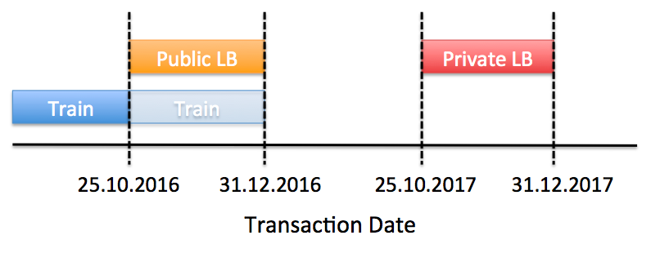

#### Distribution of transaction dates

As shown in the figure above, there are only some of the transactions after 25.10 in the train set, because the rest is in the test set (for the public LB).

tmp <- transactions %>% mutate(year_month = make_date(year=year(date),month=month(date)))

tmp %>%

group_by(year_month) %>% count() %>%

ggplot(aes(x=year_month,y=n)) +

geom_bar(stat="identity", fill="red")+

geom_vline(aes(xintercept=as.numeric(as.Date("2016-10-01"))),size=2)

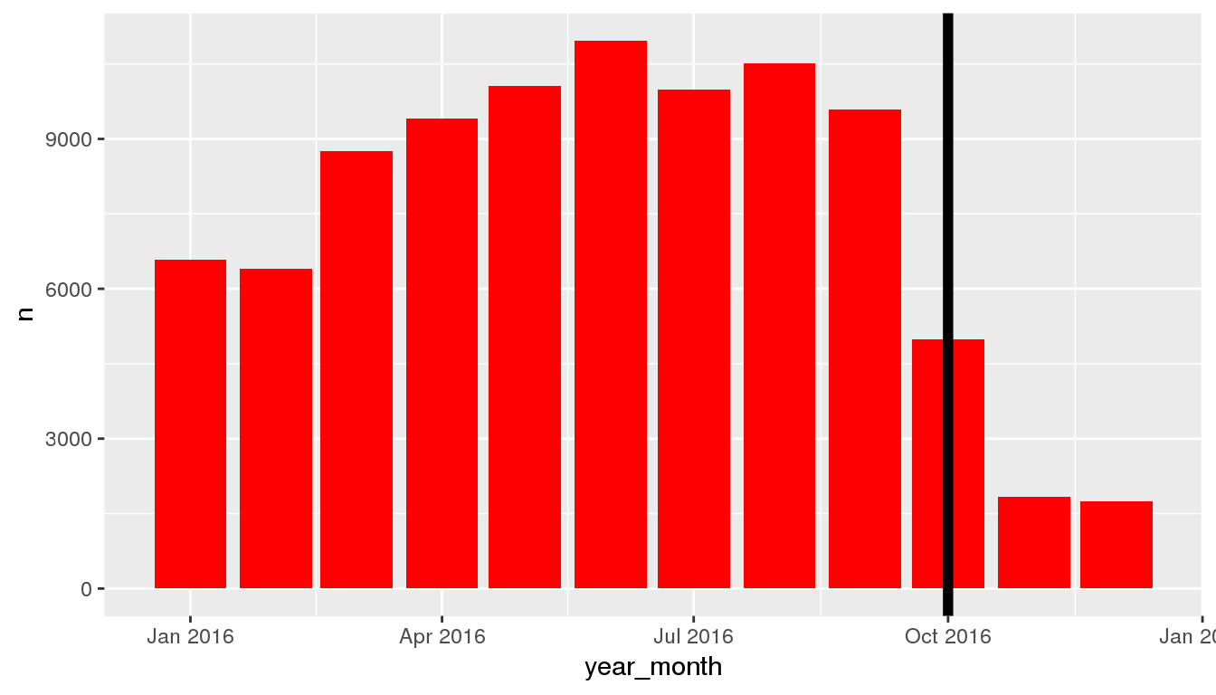

### Outcome

To get a feel for the data let’s first have a look at the distribution of our outcome (logerror), i.e. the difference in log(Zestimate)-log(Saleprice)

transactions %>%

ggplot(aes(x=logerror)) +

geom_histogram(bins=400, fill="red")+

theme_bw()+theme(axis.title = element_text(size=16),axis.text = element_text(size=14))+

ylab("Count")+coord_cartesian(x=c(-0.5,0.5))

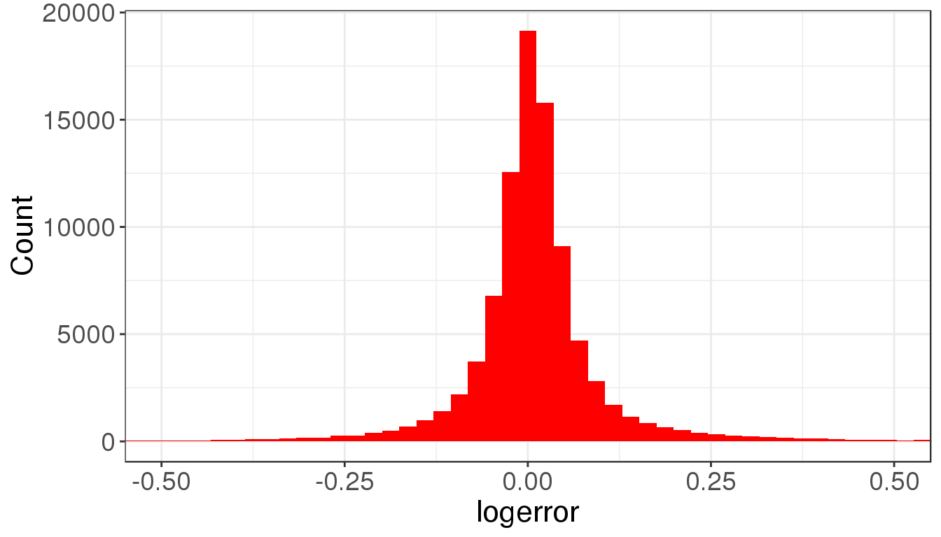

### More thoughts about the outcome

In fact there are two outcomes you can look at:

* logerror: log(Zestimate) - log(Saleprice). So a positive logerror means Zestimate is overestimating the Saleprice, a negative logerror means that Zestimate is underestimating Saleprice.
* absolute logerror: a small value means that log(Zestimate) is close to log(Saleprice). So, Zestimate predictions are close to Saleprice.

Any association with logerror would indicate that a feature would be associated with over- or understimating the sale price. Any association of a feature with absolute logerror would indicate that the feature is associated with a better or worse Zestimate.

### Absolute logerror

transactions <- transactions %>% mutate(abs_logerror = abs(logerror))

transactions %>%

ggplot(aes(x=abs_logerror)) +

geom_histogram(bins=400, fill="red")+

theme_bw()+theme(axis.title = element_text(size=16),axis.text = element_text(size=14))+

ylab("Count")+coord_cartesian(x=c(0,0.5))

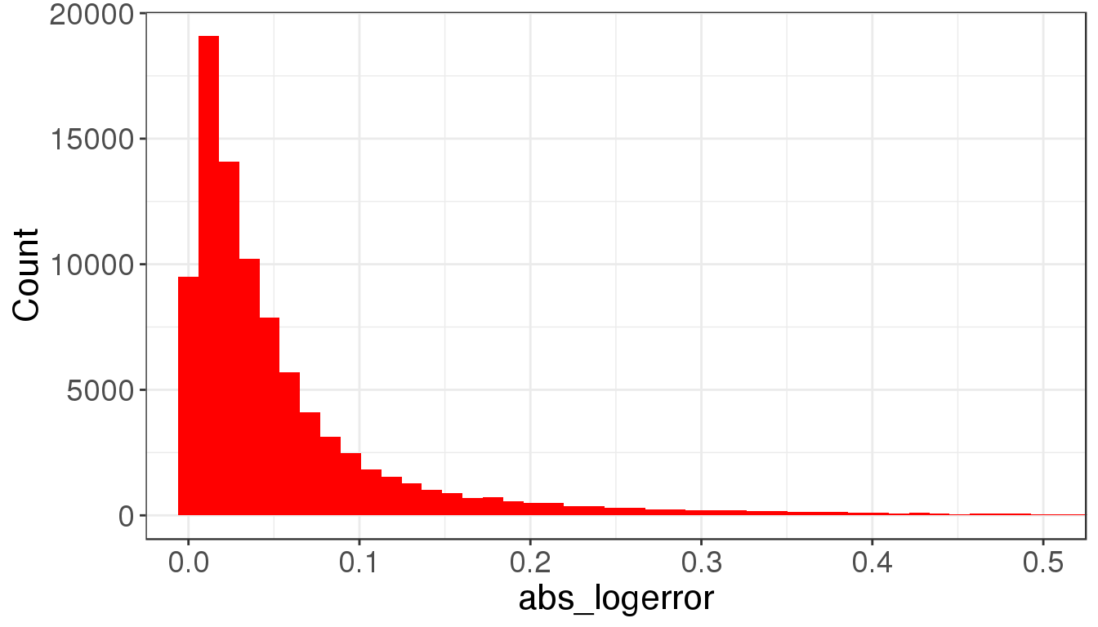

### How does absolute log error change with time

There seems to be a light trend that Zestimates error decreases over time. Predictions are getting better. Zillow seems to have good data scientists :-).

transactions %>%

mutate(year_month = make_date(year=year(date),month=month(date)) ) %>%

group_by(year_month) %>% summarize(mean_abs_logerror = mean(abs_logerror)) %>%

ggplot(aes(x=year_month,y=mean_abs_logerror)) +

geom_line(size=1.5, color="red")+

geom_point(size=5, color="red")+theme_bw()

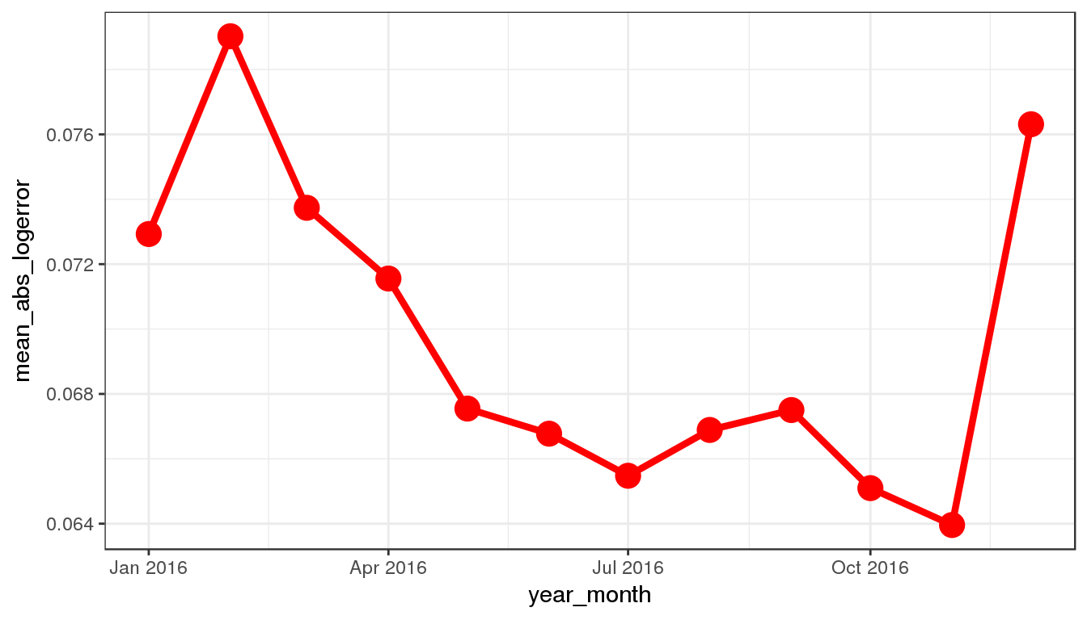

### How does log error change with time

transactions %>%

mutate(year_month = make_date(year=year(date),month=month(date)) ) %>%

group_by(year_month) %>% summarize(mean_logerror = mean(logerror)) %>%

ggplot(aes(x=year_month,y=mean_logerror)) +

geom_line(size=1.5, color="red")+geom_point(size=5, color="red")+theme_bw()

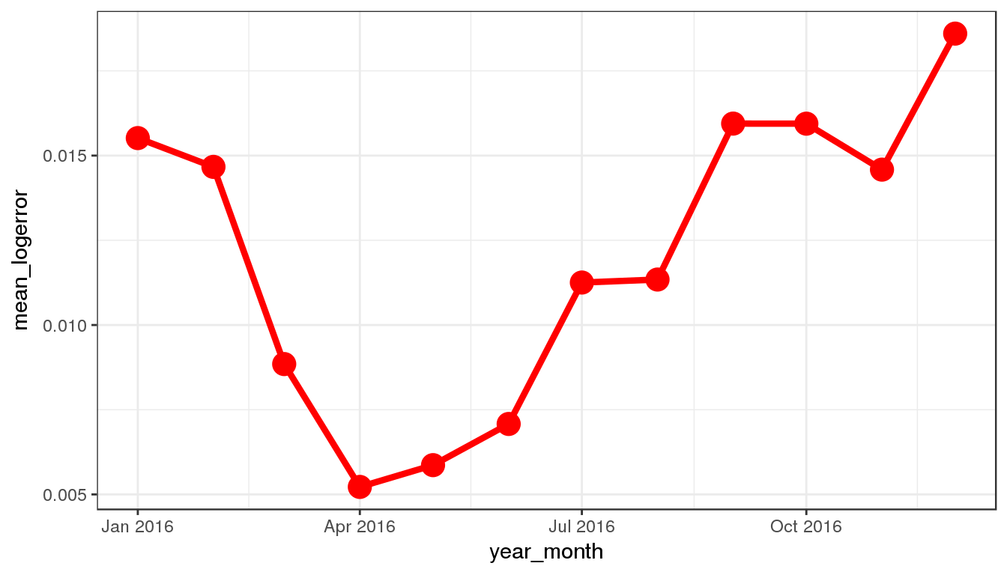

### Missing values

We have seen many missing values in the data peeking. How many missing values are there for each feature? In fact, some features are missing nearly completely. So, we probably have to work more with the others.

missing_values <- properties %>% summarize_each(funs(sum(is.na(.))/n()))

missing_values <- gather(missing_values, key="feature", value="missing_pct")

missing_values %>%

ggplot(aes(x=reorder(feature,-missing_pct),y=missing_pct)) +

geom_bar(stat="identity",fill="red")+

coord_flip()+theme_bw()

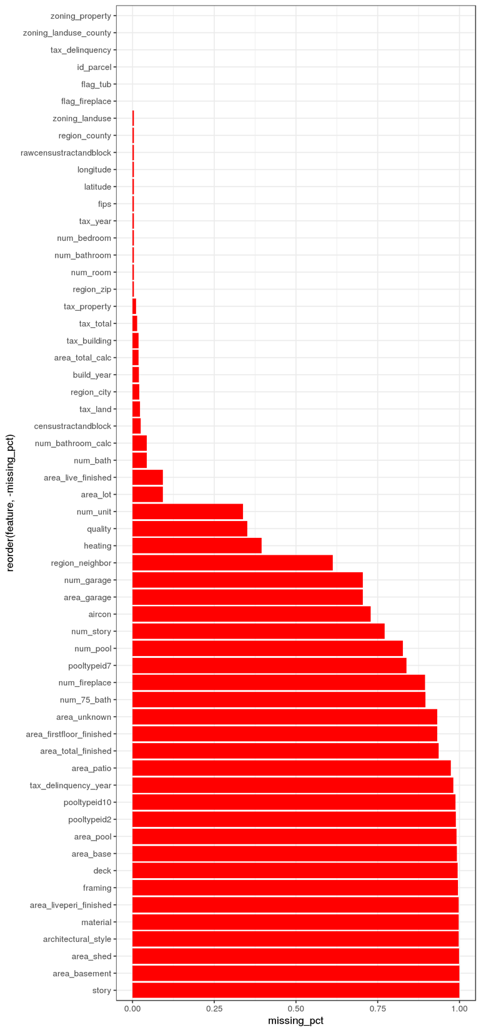

good_features <- filter(missing_values, missing_pct<0.75)

### Correlation with absolute logerror

num_ features:

vars <- good_features$feature[str_detect(good_features$feature,'num_')]

cor_tmp <- transactions %>% left_join(properties, by="id_parcel")

tmp <- cor_tmp %>% select(one_of(c(vars,"abs_logerror")))

corrplot(cor(tmp, use="complete.obs"),type="lower")

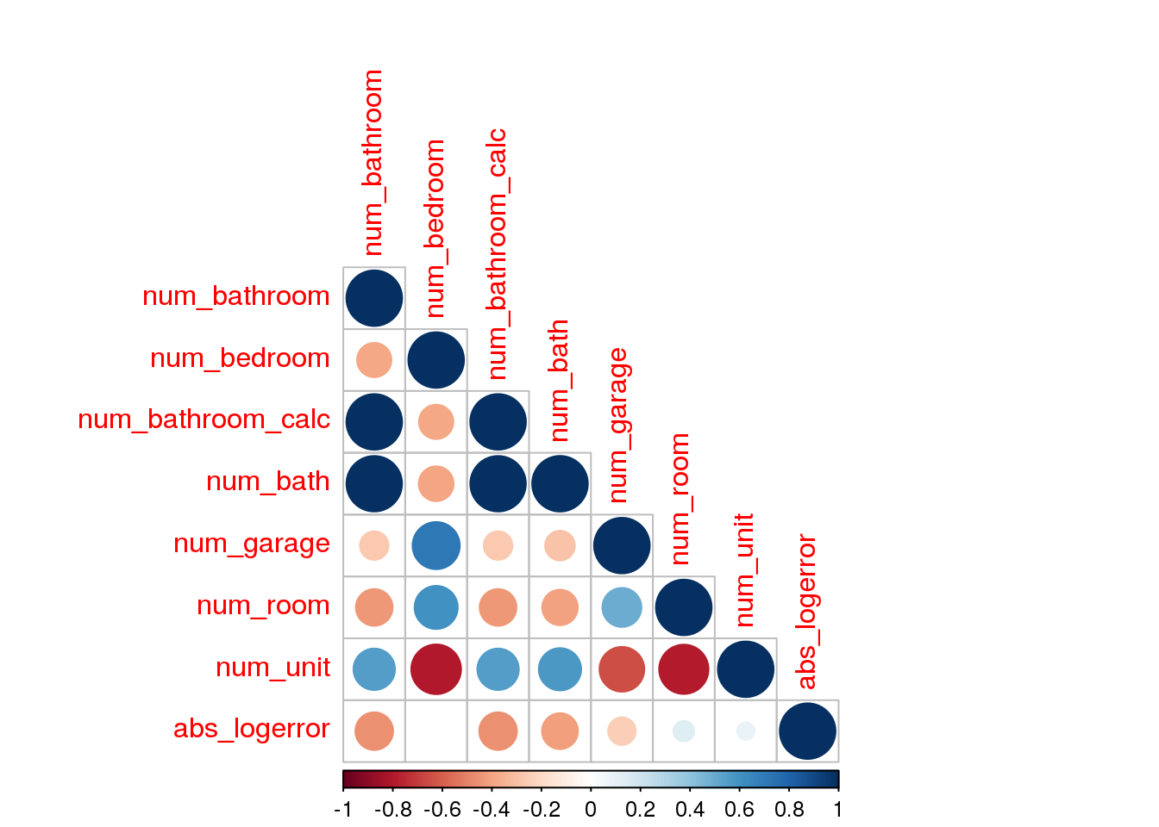

### Correlation with absolute logerror

area_ features

vars <- good_features$feature[str_detect(good_features$feature,'area_')]

tmp <- cor_tmp %>% select(one_of(c(vars,"abs_logerror")))

corrplot(cor(tmp, use="complete.obs"), type="lower")

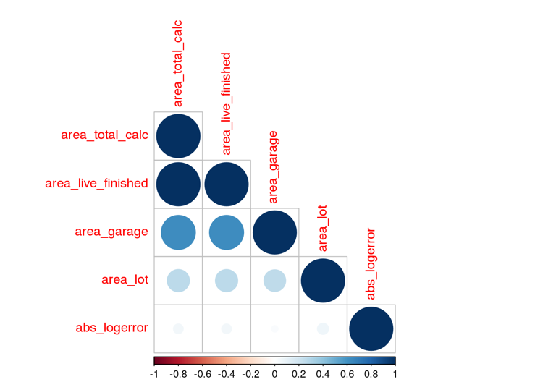

### Correlation with absolute logerror

tax_ features

vars <- setdiff(good_features$feature[str_detect(good_features$feature,'tax_')],c("tax_delinquency","tax_year"))

tmp <- cor_tmp %>% select(one_of(c(vars,"abs_logerror")))

corrplot(cor(tmp, use="complete.obs"), type="lower")

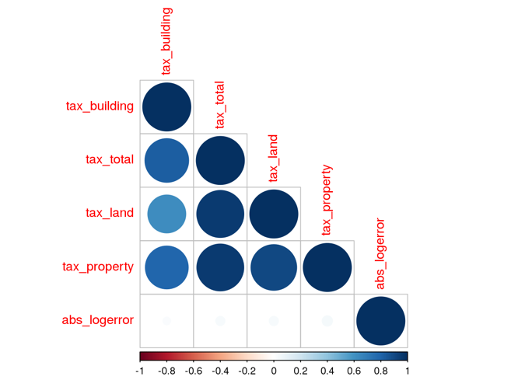

### Correlation with logerror

num_ features: There seems to be small negative correlations between the num features and logerror.

vars <- good_features$feature[str_detect(good_features$feature,'num_')]

cor_tmp <- transactions %>% left_join(properties, by="id_parcel")

tmp <- cor_tmp %>% select(one_of(c(vars,"logerror")))

corrplot(cor(tmp, use="complete.obs"),type="lower")

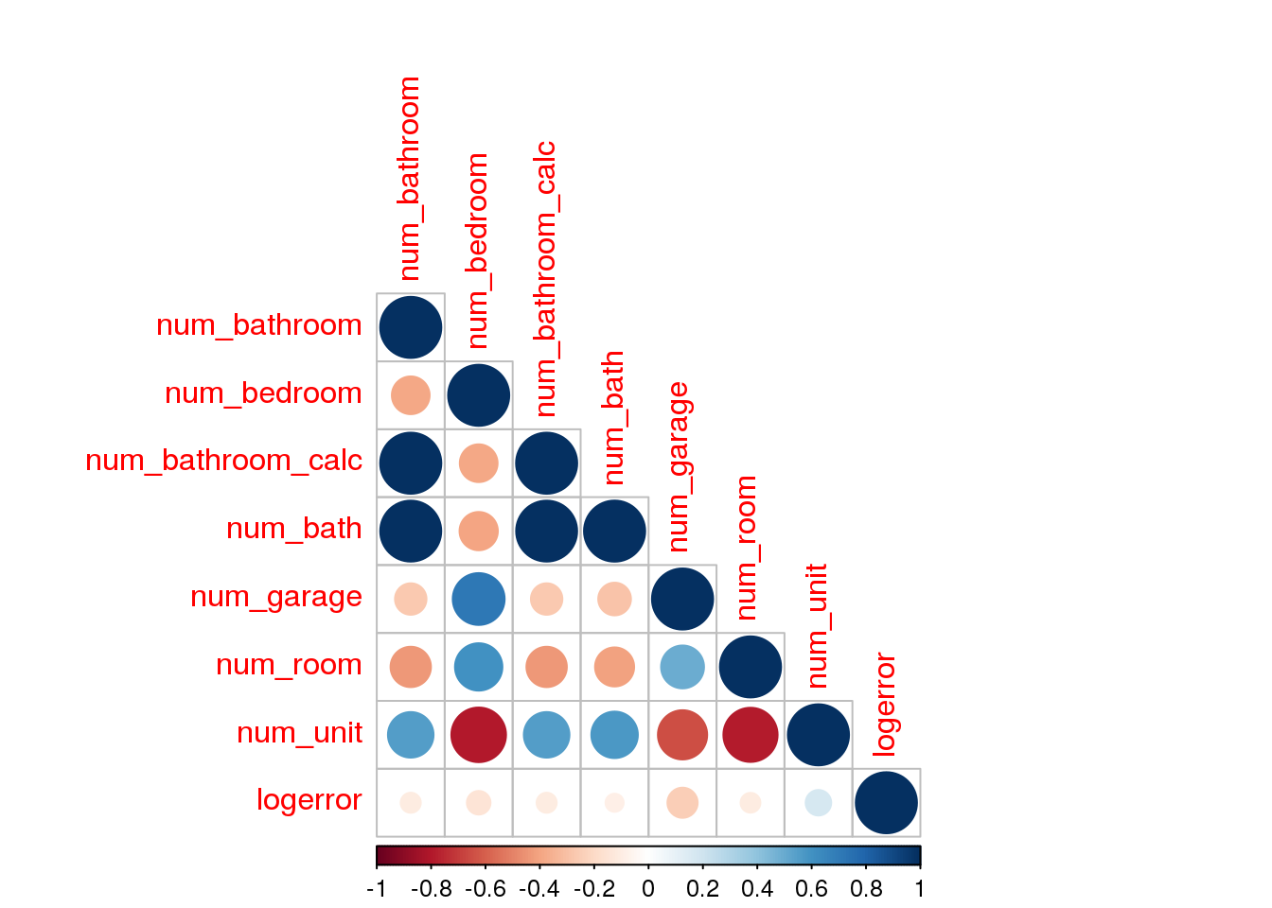

### Correlation with logerror

area_ features

vars <- good_features$feature[str_detect(good_features$feature,'area_')]

tmp <- cor_tmp %>% select(one_of(c(vars,"logerror")))

corrplot(cor(tmp, use="complete.obs"), type="lower")

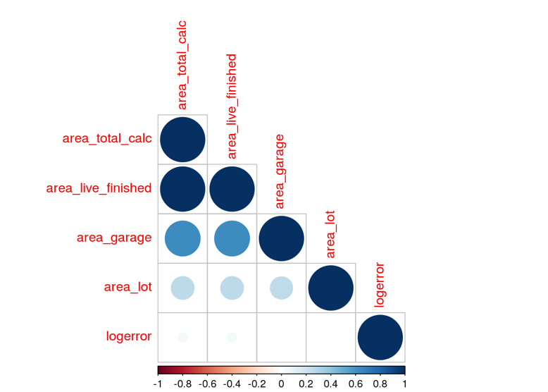

### Correlation with logerror

tax_ features

vars <- setdiff(good_features$feature[str_detect(good_features$feature,'tax_')],c("tax_delinquency","tax_year"))

tmp <- cor_tmp %>% select(one_of(c(vars,"logerror")))

corrplot(cor(tmp, use="complete.obs"), type="lower")

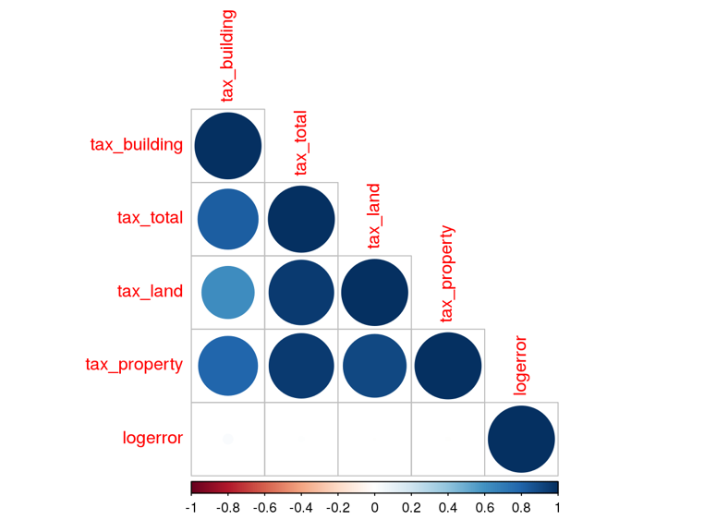

### How does the absolute logerror change with build_year?

cor_tmp %>%

group_by(build_year) %>%

summarize(mean_abs_logerror = mean(abs(logerror))) %>%

ggplot(aes(x=build_year,y=mean_abs_logerror))+

geom_smooth(color="grey40")+

geom_point(color="red")+coord_cartesian(ylim=c(0,0.25))+theme_bw()

## `geom_smooth()` using method = 'loess' and formula 'y ~ x'

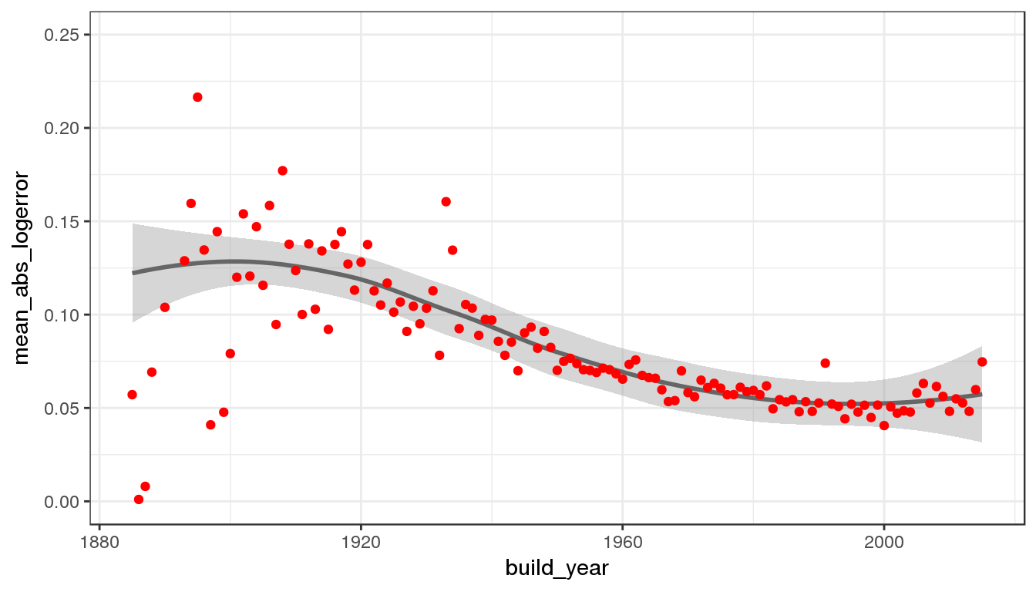

### How does the logerror change with build_year?

cor_tmp %>%

group_by(build_year) %>%

summarize(mean_logerror = mean(logerror)) %>%

ggplot(aes(x=build_year,y=mean_logerror))+

geom_smooth(color="grey40")+

geom_point(color="red")+coord_cartesian(ylim=c(0,0.075))+theme_bw()

## `geom_smooth()` using method = 'loess' and formula 'y ~ x'

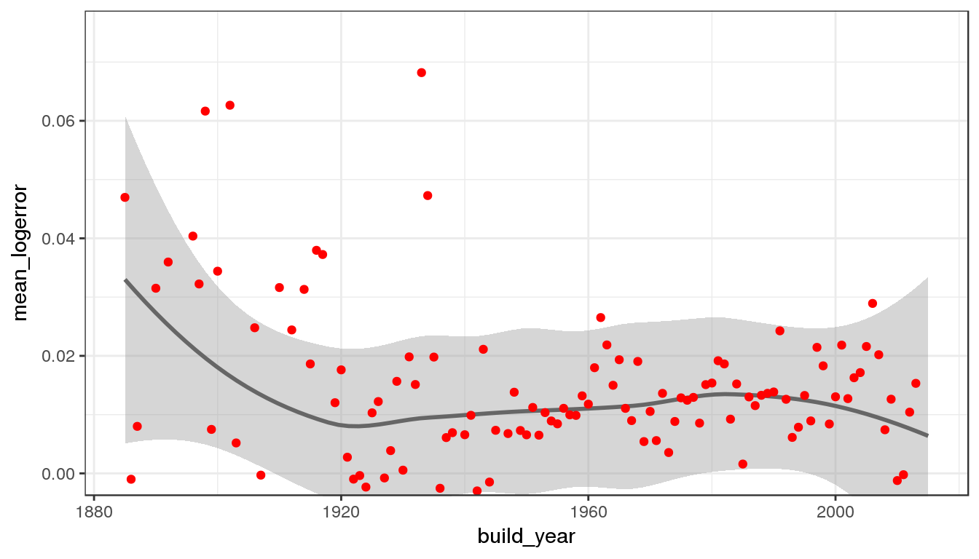

### Where does Zestimate predict well?

To get a quick feel where zestimate predicts well, we can group our absolute logerror into different percentiles, e.g. the percentile with best predictions (top 10%), worst predictions (worst 10%) and typical predictions (50% around the median).

transactions <- transactions %>% mutate(percentile = cut(abs_logerror,quantile(abs_logerror, probs=c(0, 0.1, 0.25, 0.75, 0.9, 1),names = FALSE),include.lowest = TRUE,labels=FALSE))

tmp1 <- transactions %>%

filter(percentile == 1) %>%

sample_n(5000) %>%

left_join(properties, by="id_parcel")

tmp2 <- transactions %>%

filter(percentile == 5) %>%

sample_n(5000) %>%

left_join(properties, by="id_parcel")

tmp3 <- transactions %>%

filter(percentile == 3) %>%

sample_n(5000) %>%

left_join(properties, by="id_parcel")

tmp1 <- tmp1 %>% mutate(type="best_fit")

tmp2 <- tmp2 %>% mutate(type="worst_fit")

tmp3 <- tmp3 %>% mutate(type="typical_fit")

tmp <- bind_rows(tmp1,tmp2,tmp3)

tmp <- tmp %>% mutate(type = factor(type,levels = c("worst_fit", "typical_fit", "best_fit")))

If the distributions of features are largely overlapping for these three groups of transactions the feature most likely does not have a large effect on the goodness of estimation. Let’s see one example.

col_pal <- "Set1"

tmp %>% ggplot(aes(x=latitude, fill=type, color=type)) + geom_line(stat="density", size=1.2) + theme_bw()+scale_fill_brewer(palette=col_pal)+scale_color_brewer(palette=col_pal)

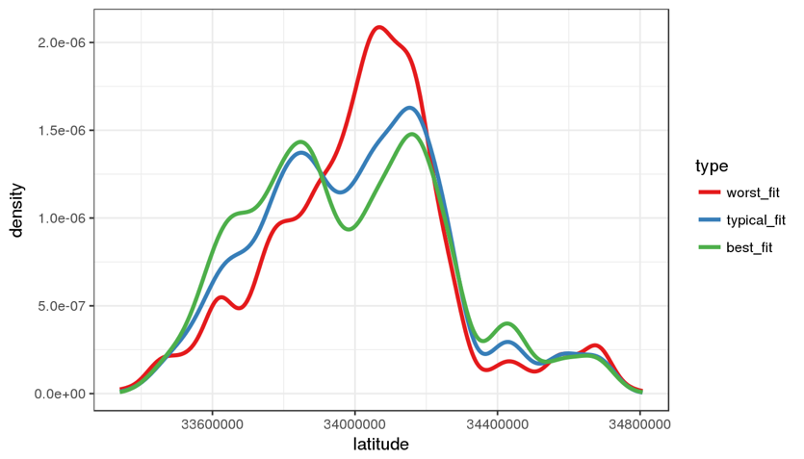

tmp %>% ggplot(aes(x=latitude, fill=type, color=type, group=type)) + geom_line(stat="density", size=1.2)+theme_bw()+scale_fill_brewer(palette=col_pal)+scale_color_brewer(palette=col_pal)

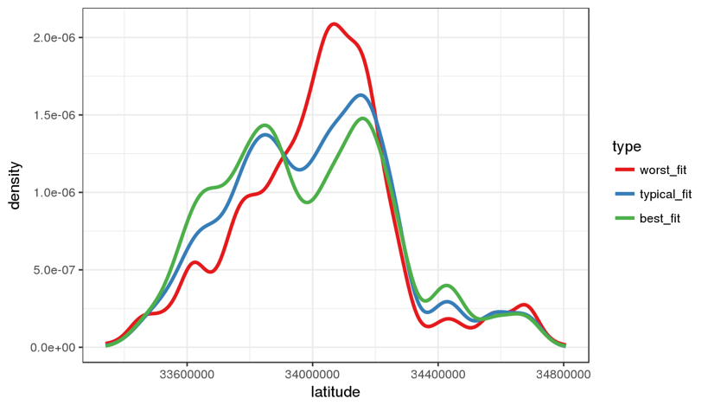

We can see that rows resulting in the worst predictions have a lower density for lower latitude values, but a higher density for intermediate latitudes (around 34000000).

We can examine this effect more closely and plot the absolute logerror as a function of latitude.

tmptrans <- transactions %>%

left_join(properties, by="id_parcel")

tmptrans %>%

ggplot(aes(x=latitude,y=abs_logerror))+geom_smooth(color="red")+theme_bw()

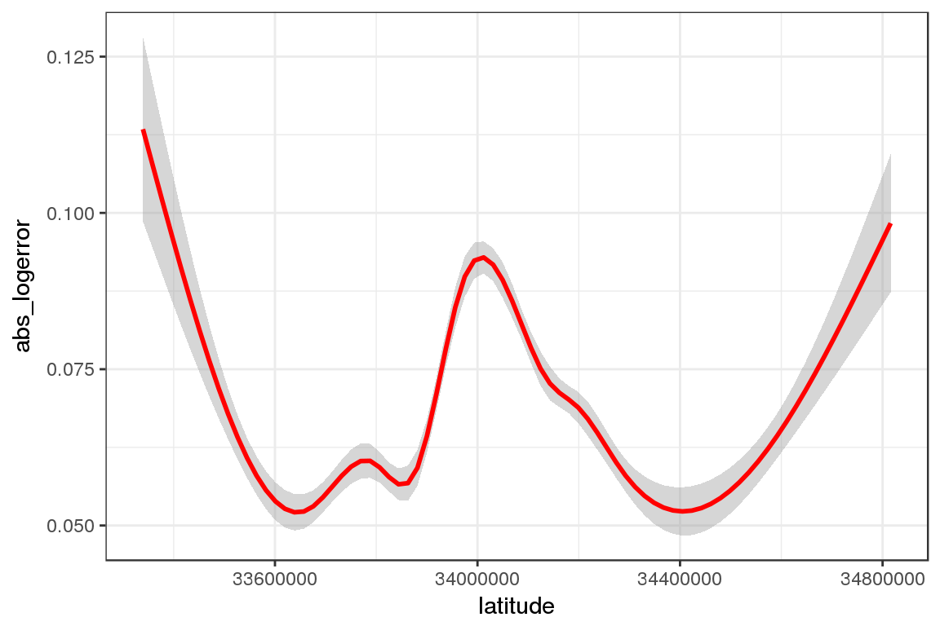

Having seen the example, we can look at other features quickly, to see which are associated with absolute logerror.

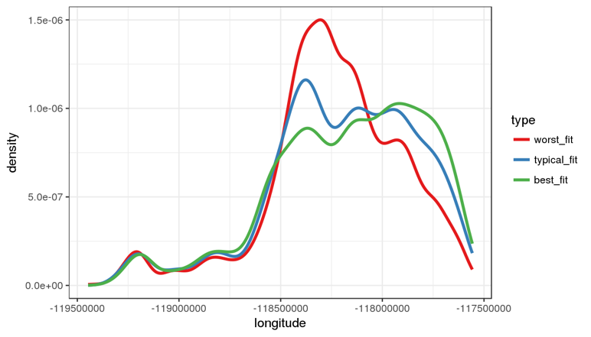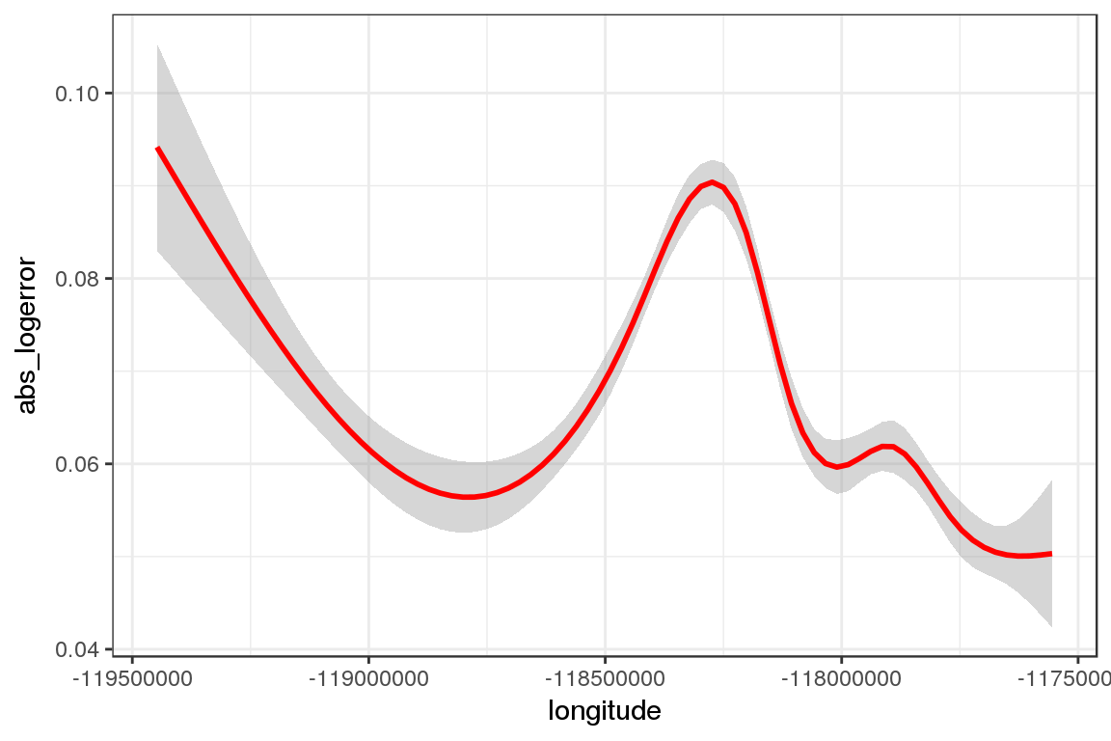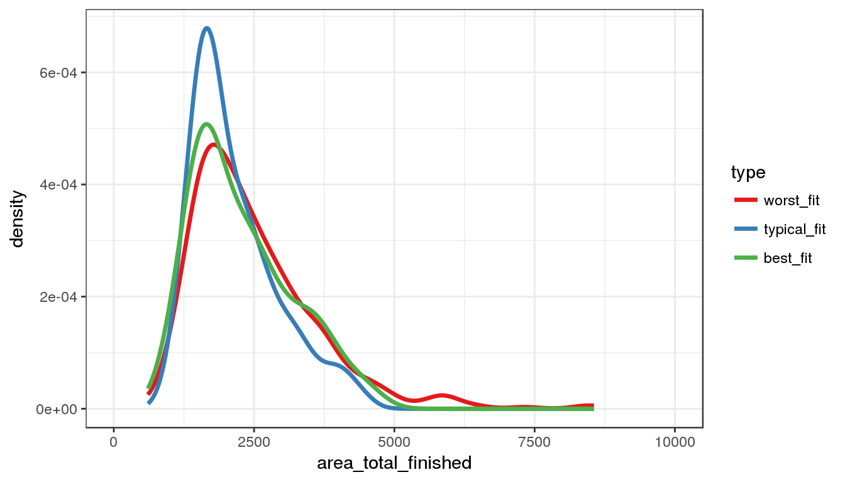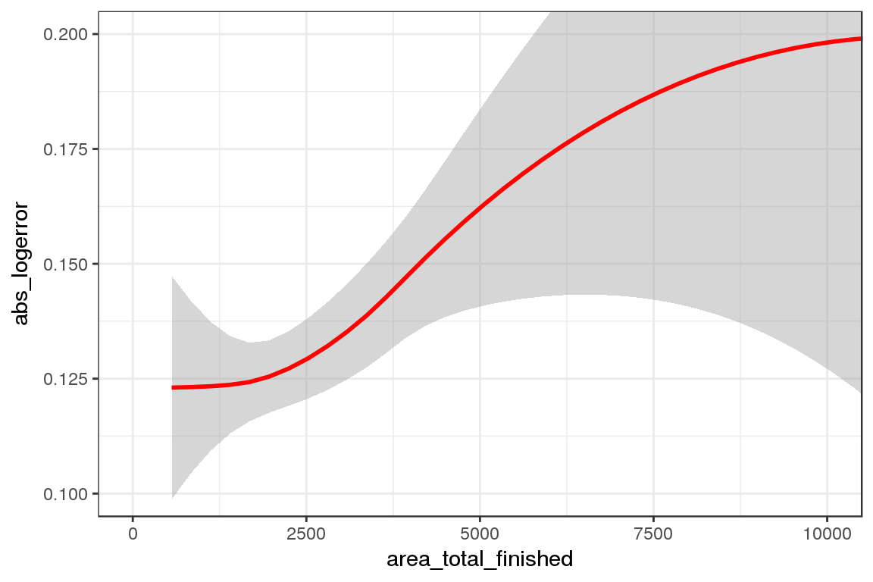

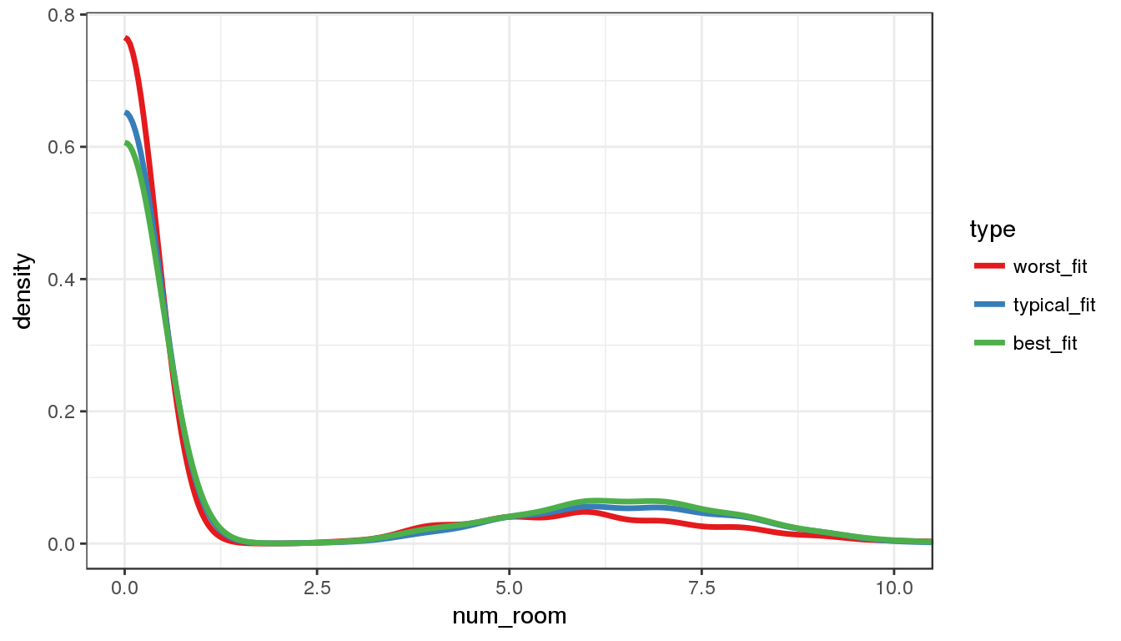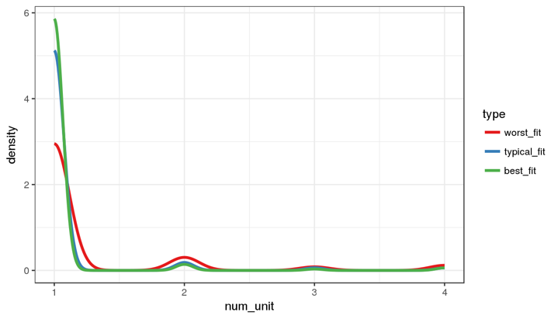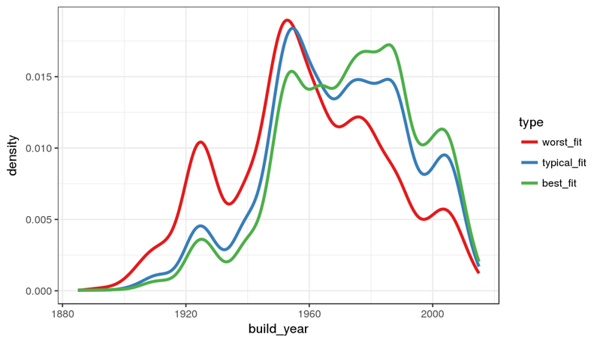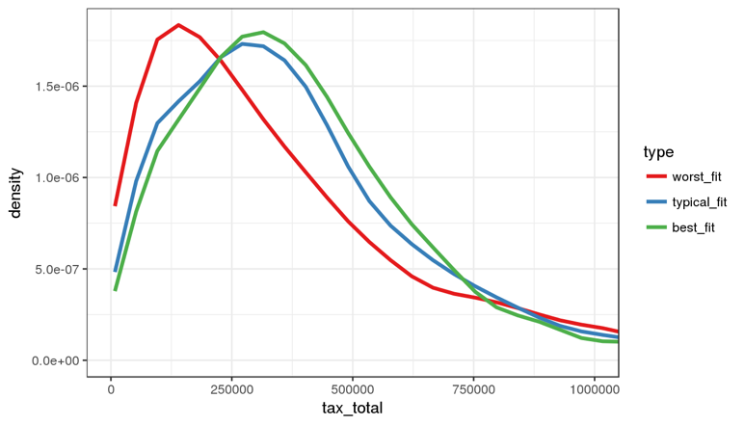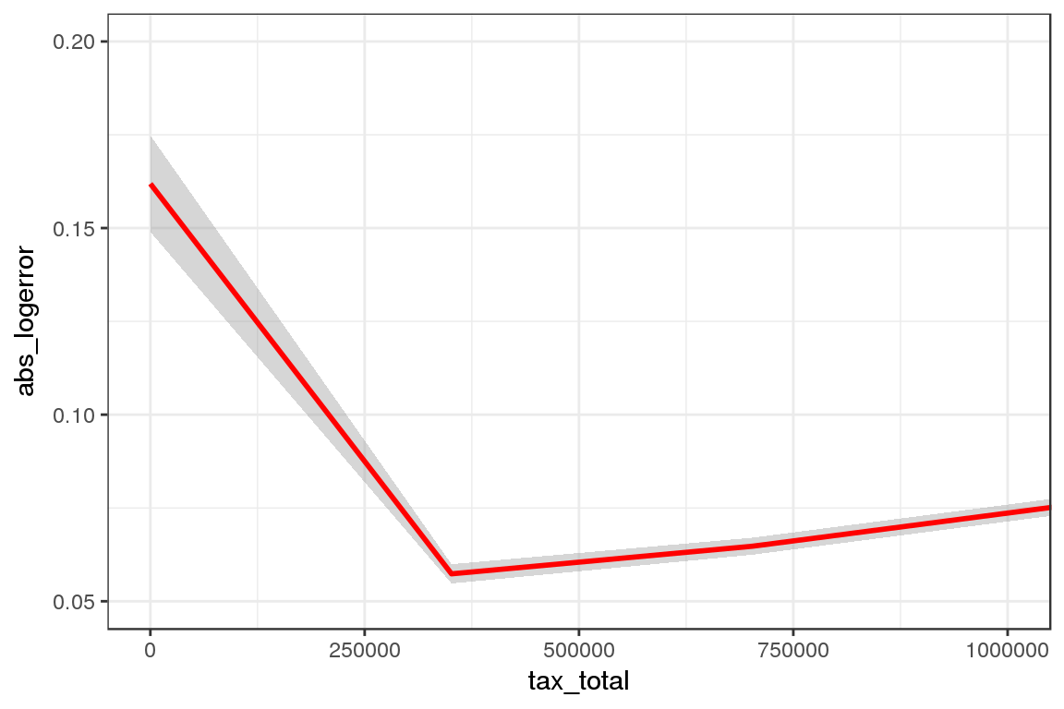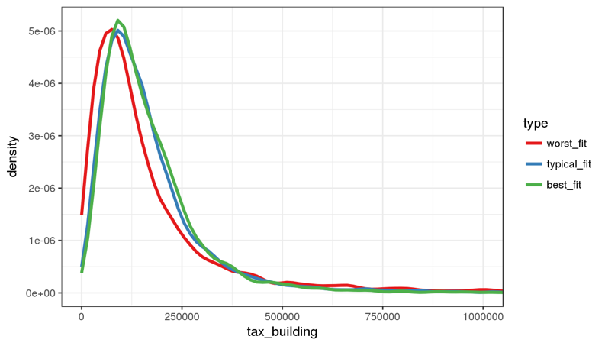

### Where does Zestimate over or underpredict?

A high absolute logerror tells us predictions are not that good. But this could either be driven by underpredicting or overpredicting sale price.

tmptrans <- tmptrans %>% mutate(overunder = ifelse(logerror<0,"under","over"))

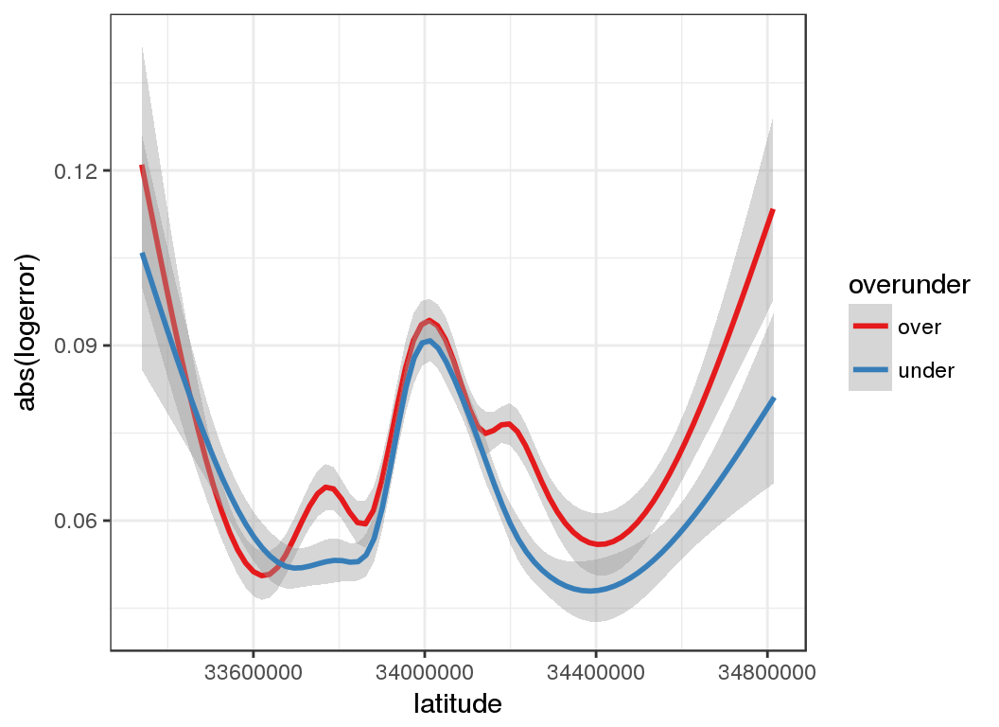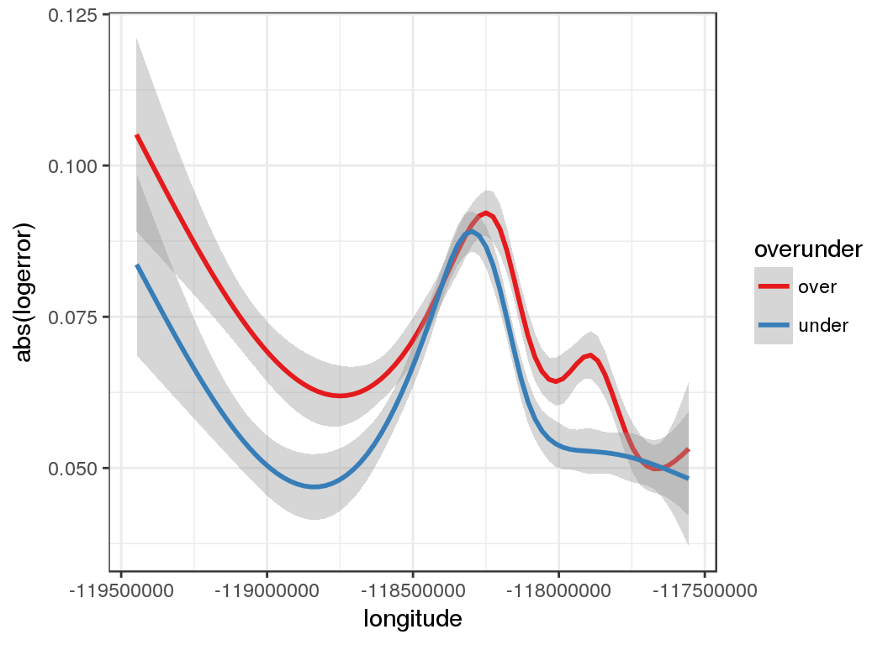

For properties with small total area, Zestimate seems to overpredict. 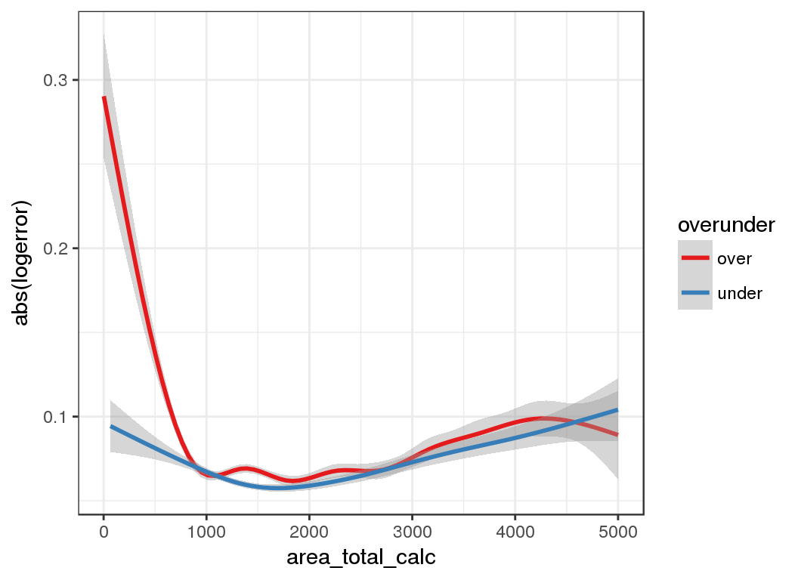

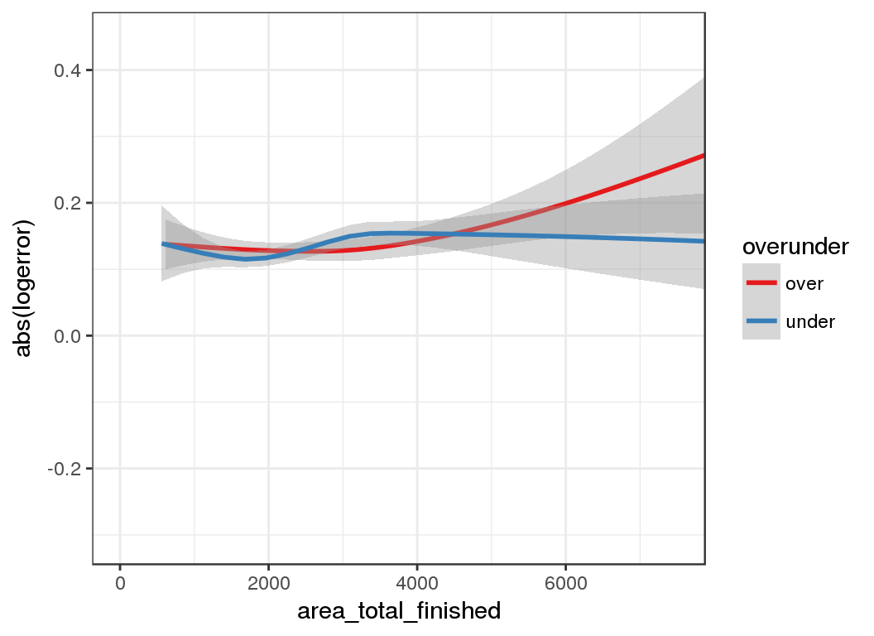

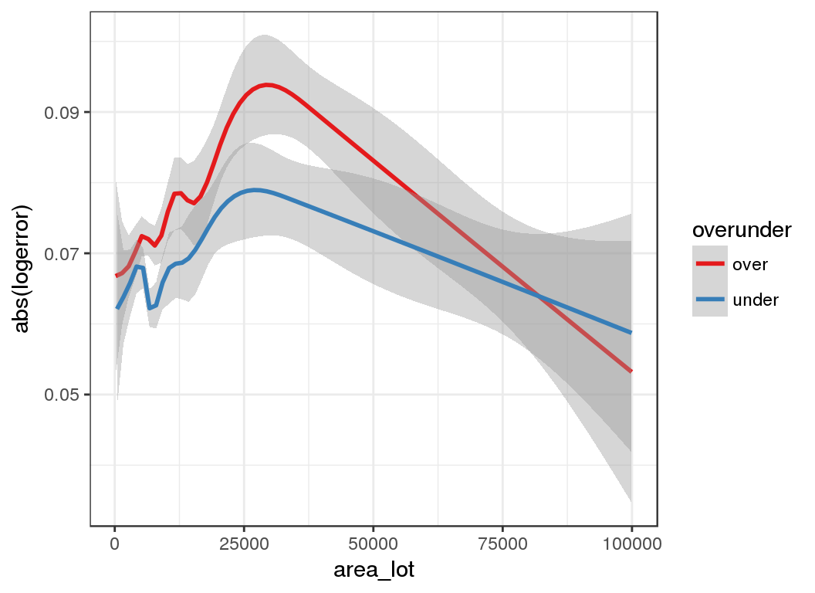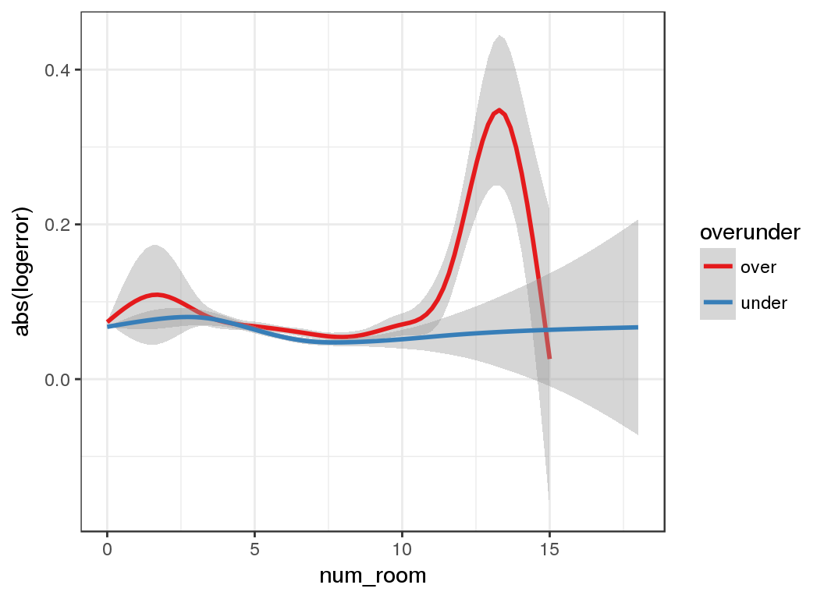

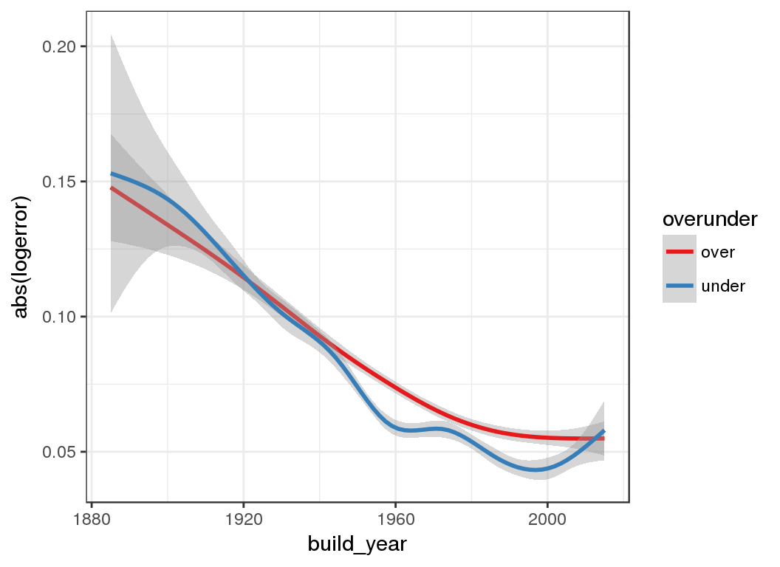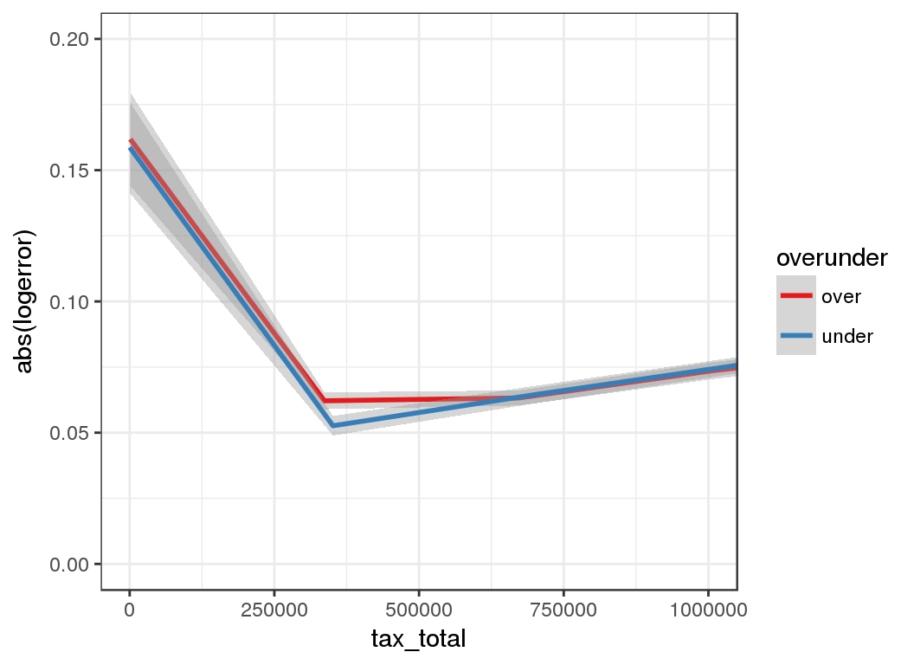

### Where are all those properties?

Show 2,000 of the properties on the map.

lat <- range(properties$latitude/1e06,na.rm=T)

lon <- range(properties$longitude/1e06,na.rm=T)

tmp <- properties %>%

sample_n(2000) %>%

select(id_parcel,longitude,latitude) %>%

mutate(lon=longitude/1e6,lat=latitude/1e6) %>%

select(id_parcel,lat,lon) %>%

left_join(transactions,by="id_parcel")

leaflet(tmp) %>%

addTiles() %>%

fitBounds(lon[1],lat[1],lon[2],lat[2]) %>%

addCircleMarkers(stroke=FALSE) %>%

addMiniMap()

[+-](https://www.kaggle.io/svf/1197101/205cfffc70ec42601188bd14d6dc512d/__results__.html)

[Leaflet](http://leafletjs.com) | © [OpenStreetMap](http://openstreetmap.org) contributors, [CC-BY-SA](http://creativecommons.org/licenses/by-sa/2.0/)

### Map absolute logerror

Show the absolute logerror on map. Red = higher.

tmp <- transactions %>%

sample_n(2000) %>%

left_join(properties,by="id_parcel") %>%

select(id_parcel,longitude,latitude, abs_logerror) %>%

mutate(lon=longitude/1e6,lat=latitude/1e6) %>%

select(id_parcel,lat,lon, abs_logerror)

qpal <- colorQuantile("YlOrRd", tmp$abs_logerror, n = 7)

leaflet(tmp) %>%

addTiles() %>%

fitBounds(lon[1],lat[1],lon[2],lat[2]) %>%

addCircleMarkers(stroke=FALSE, color=~qpal(abs_logerror),fillOpacity = 1) %>%

addLegend("bottomright", pal = qpal, values = ~abs_logerror,title = "Absolute logerror",opacity = 1) %>%

addMiniMap()

[+-](https://www.kaggle.io/svf/1197101/205cfffc70ec42601188bd14d6dc512d/__results__.html)

**Absolute logerror**

0% – 14%  
14% – 29%  
29% – 43%  
43% – 57%  
57% – 71%  
71% – 86%  
86% – 100%

[Leaflet](http://leafletjs.com) | © [OpenStreetMap](http://openstreetmap.org) contributors, [CC-BY-SA](http://creativecommons.org/licenses/by-sa/2.0/)

### What do these features mean?

I was really unsure about the meaning of the variables:

* ‘rawcensustractandblock’

A wikipedia search revealed:

Census tracts represent the smallest territorial unit for which population data are available in many countries.[3] In the United States, census tracts are subdivided into block groups and census blocks. In the U.S., census tracts are “designed to be relatively homogeneous units with respect to population characteristics, economic status, and living conditions” and “average about 4,000 inhabitants”.

Ok thats interesting. This opens up the possibility to incorporate external data from census into the analysis. So it’s worth exploring further:

str(properties$rawcensustractandblock[1])

## num 60378002

Looks like a number. However a closer look reveals its actually a number composed of two parts, separated by a dot.

as.character(properties$rawcensustractandblock[1])

## [1] "60378002.041"

Ok, so far so good. So from what I read this number consisits of: FIPS Code (6037) - Tract Number (8002.04) - And block Number (1)

Let’s specifically add the tract number and block number information

properties <- properties %>% mutate(census = as.character(rawcensustractandblock), tract_number = str_sub(census,5,11), tract_block = str_sub(census,12))

FIPS codes can be looked up [here](https://www.ffiec.gov/census/Default.aspx)

* 6037 Los Angeles
* 6059 Orange County
* 6111 Ventura County

Now, that you have the tract number you can get information such as tract income level, median family income, tract population, etc. **This might really be valueable information for the prediction**

For our example “6037 8002.04” lets look up some information:

<https://www.ffiec.gov/census/report.aspx?year=2016&county=037&tract=8002.04&state=06&report=demographic>

For example: The median familiy income 2016 is $146,472.

Good to know. This really might help our models.

So I wish you some happy information gathering.

**An important note:**

Please check the competition rules first whether external data is allowed.

I am going to add more information later. So stay tuned.

And:

If the kernel helped you and you **upvote**, you make me happy :-)